**Overview:**

There were a few modules that were used in the creation of this program:

Pygame - <https://www.pygame.org/wiki/about>

Tkinter - <https://docs.python.org/3/library/tkinter.html>

Random - <https://docs.python.org/3/library/random.html>

Time - <https://docs.python.org/3/library/time.html>

Also a few websites were used to aid with the development of this program. They are listed in the reference and include websites such as:

* <https://realpython.com/pygame-a-primer/> - initial tutorial for pygame basics
* <https://www.pygame.org/docs/> - check pygame features throughout project
* <https://realpython.com/python-gui-tkinter/> - initial tutorial for tkinter basics

A mini contents of this section is listed below:

* **PHASE 1:**
  + Player class [Player_class] (page 3)
  + Wall class [Maze_objects] (page 6)
  + Cell class [Maze_objects] (page 6)
  + Empty class [Maze_objects] (page 6)
  + pygame_window class [Main] (page 7)
  + Game class - version 1 [Main] (page 7)
  + generate_maze function [Main] (page 8)
  + create_paths function [Main] (page 8-10)
  + Key class [Maze_objects] (page 11)
* **PHASE 2:**
  + Scoreboard class [Information_objects] (page 14)
  + Lives class [Information_objects] (page 14)
  + Moves class [Information_objects] (page 15)
  + Timer class [Information_objects] (page 15)
  + Title class [Starting_objects] (page 17)
  + Controls class [Starting_objects] (page 18)
  + Play class [Starting_objects] (page 18)
  + Instructions class [Starting_objects] (page 18)
  + Quit class [Starting_objects] (page 18)
  + controlsImage and instructionsImage classes [Other_objects] (page 19)
  + start_screen class [Main] (page 19-20)
  + controls_screen class [Main] (page 20)
  + instructions_screen class [Main] (page 21)
  + Game class - version 2 [Main] (page 21)
  + winScreen and loseScreen classes (page 24)
  + Game class - version 3 [Main] (page 24)
  + win_screen class [Main] (page 25)
  + lose_screen class [Main] (page 25)
* **PHASE 3:**
  + App class [Maths_quiz] (page 27)
  + get_questions function [Maths_quiz] (page 27)
  + Window class [Maths_quiz] (page 28)
  + Results class [Maths_quiz] (page 29)
* **PHASE 4:**
  + screens class {interface} [Main] (page 33)
  + GameSave class [GameSave_class] (page 34)
  + SaveButton and LoadButton classes [Information_objects] (page 35)
  + SS_image and LS_image classes [Other_objects] (page 36)
  + save_screen class [Main] (page 37)
  + load_screen class [Main] (page 38-39)
  + HighScores class [HighScores_class] (page 43)
  + high_scores_screen1 class [Main] (page 44)
  + high_scores_screen2 class [Main] (page 45)
* **PHASE 5:**
  + Text1 class [QS_objects] (page 47)
  + Button1 - Button5 classes [QS_objects] (page 47-48)
  + QuestionSelect_screen class [Main] (page 49-50)
  + Game class - version 4 [Main] (page 52)
  + get_questions function [Main] (page 52)
  + QuestionWindow [Main] (page 54)
  + MovesStack [Stack_class] (page 60)
  + UndoButton [Information_objects] (page 61)
* **PHASE 6:**
  + recursiveSolve function [Main] (page 64)
  + revealHint function [Main] (page 64)
  + HintButton [Information_objects] (page 65)

A list of key technical features, with directions as to where they are discussed in the document, can be seen below:

* OOP (Object Oriented Programming)
  + OOP used throughout e.g. many classes used such as the Player class, Title class, pygame_window class and many, many more
  + Inheritance used to inherit from screens (an interface) and also for sprites to inherit from general sprite class (in pygame module)
  + Compositional aggregation used to instantiate screens e.g. start_screen, controls_screen, win_screen etc within the Game class and also instantiate the sprites within the different screens e.g pygame_window, lose_screen etc.
  + Interface used (screens) which is the base class for 7+ subclasses.
* Prim’s algorithm implementation
  + 2 dimensional array used to store maze (True for Cell, False for Wall)
  + Random module used to select wall from array
* Recursive solving implementation
  + 2 dimensional array used to store solved path (True for Cell, False for Wall)
  + Used as part of the hints system to reveal part of the maze path to the user
  + Depends on visited 2D array
* Merge sort
  + Used to sort out the high scores before re-writing the file
* File handling
  + Used to get Maths questions from file
  + Also used to get high scores from file
  + Used to re-write high scores with new score added
  + Also used to write game info to a file when saving the game
  + Used to load game info from a file when loading a previously saved game
* Save/Load game feature
  + This will allow the user to save the game and so key details about the game will be written to a file
  + It will also allow the user to load in a previously saved game
* Advanced programming style
  + Mostly OOP used but some procedural
  + Interface used as base class for a few classes
  + Subprograms used to group similar classes together
  + Methods and Objects encapsulated and localised, getter methods used to pass attributes to main part of program/other classes
  + Code laid out logically and classes confined to their function only - no class is handling bits of everything
  + Classes are kept separate and communicate together when required.

**Phase 1:**

The first thing I decided to do was to create my Player class. This was done as a subprogram and commented throughout.

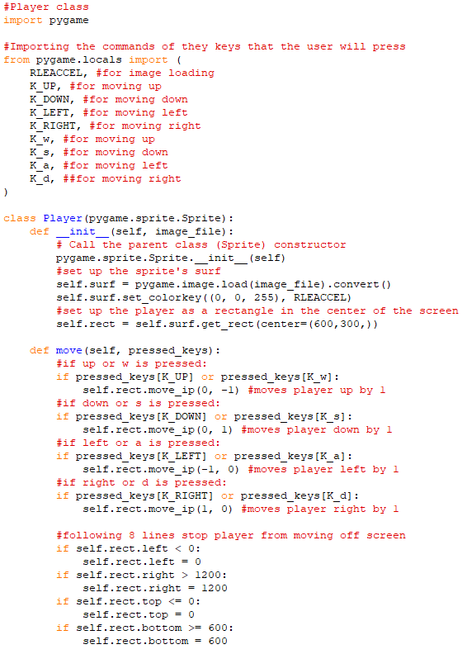

I then decided to test it by initialising pygame and creating an instance of Player.

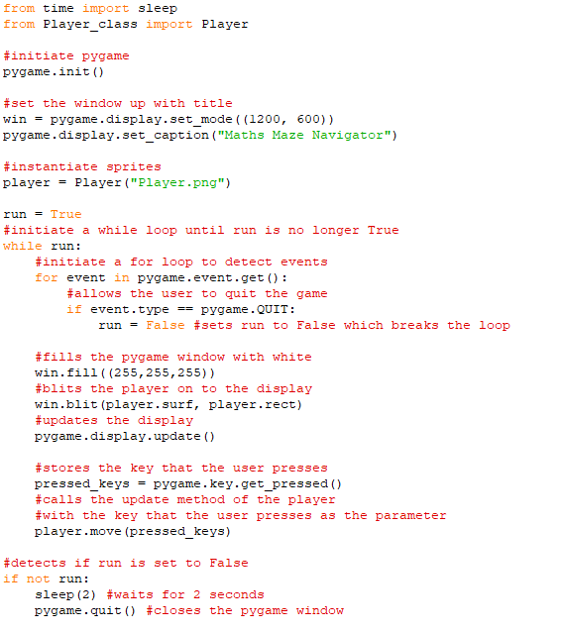 Here is the program running in pygame: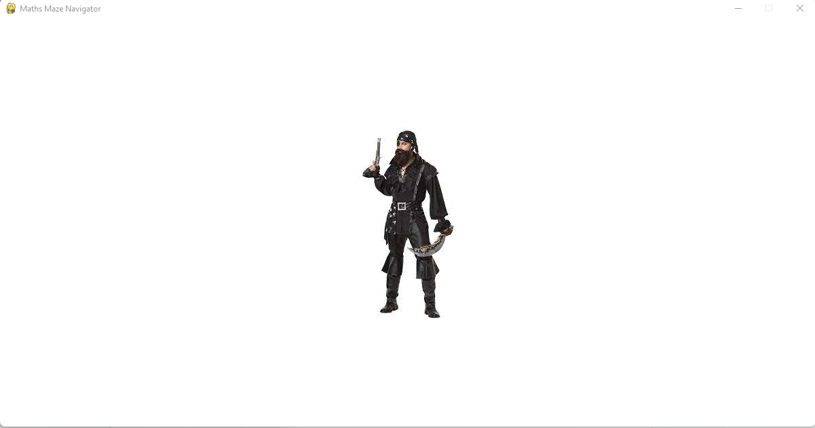

After pressing RIGHT once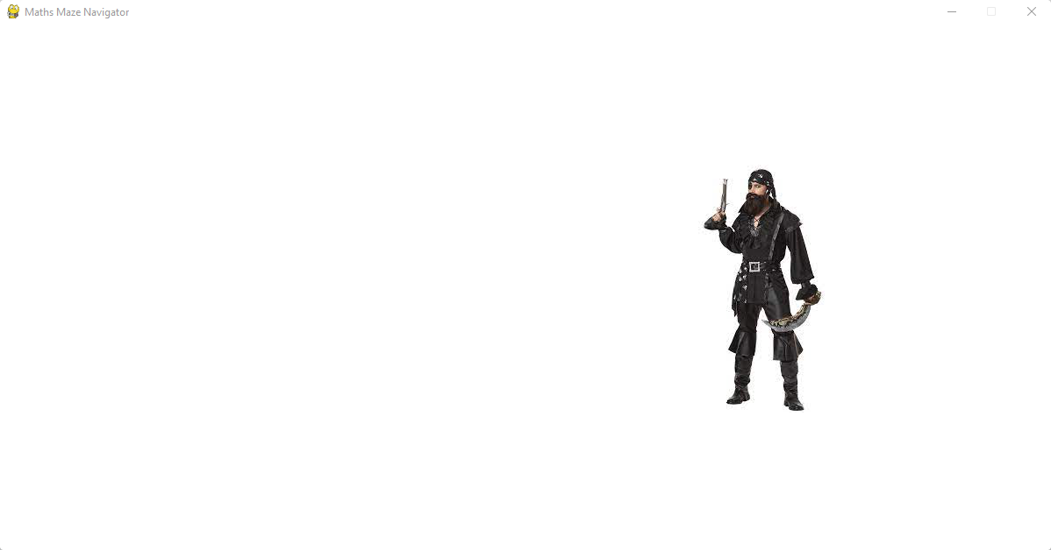

After pressing UP once:

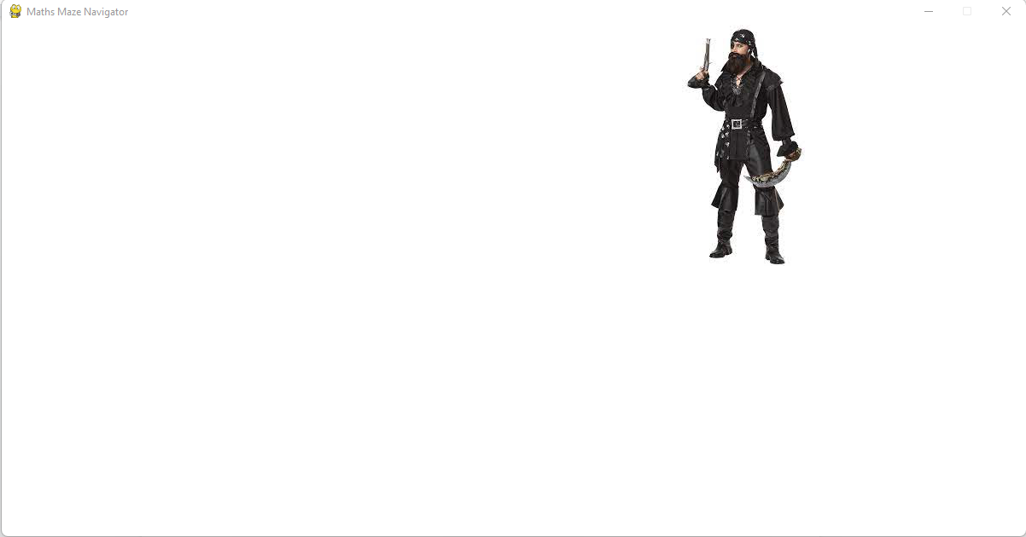

After pressing LEFT multiple times:

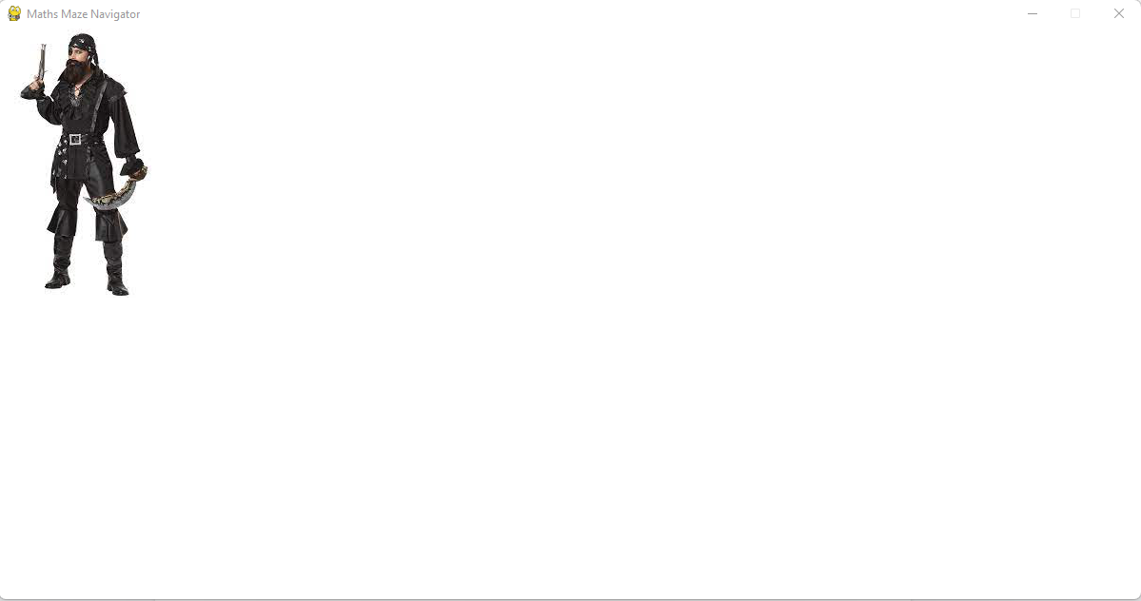

After pressing DOWN multiple times:

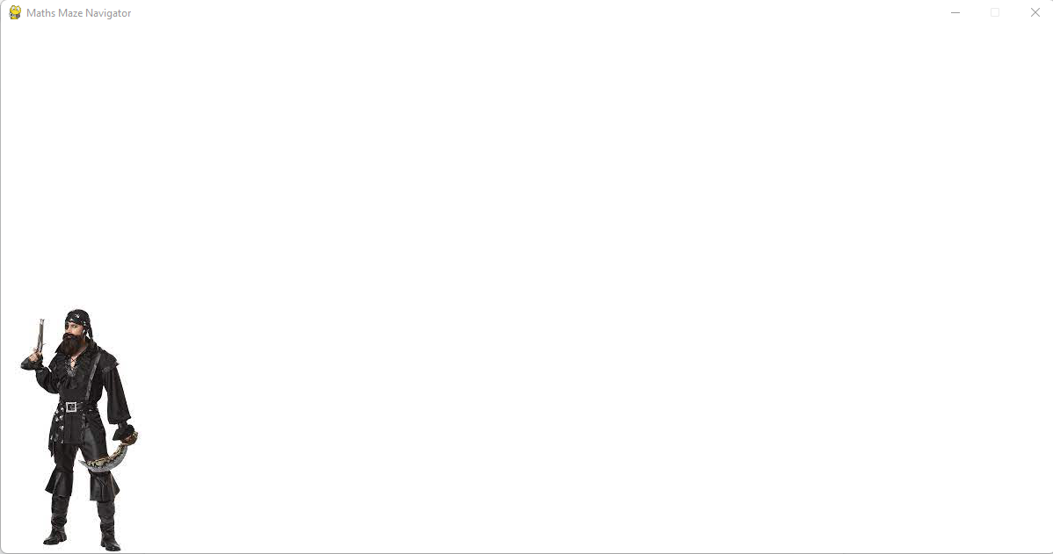

Next I decided to create the Cell, Wall and Empty classes. These were also done in a sub program and commented throughout.

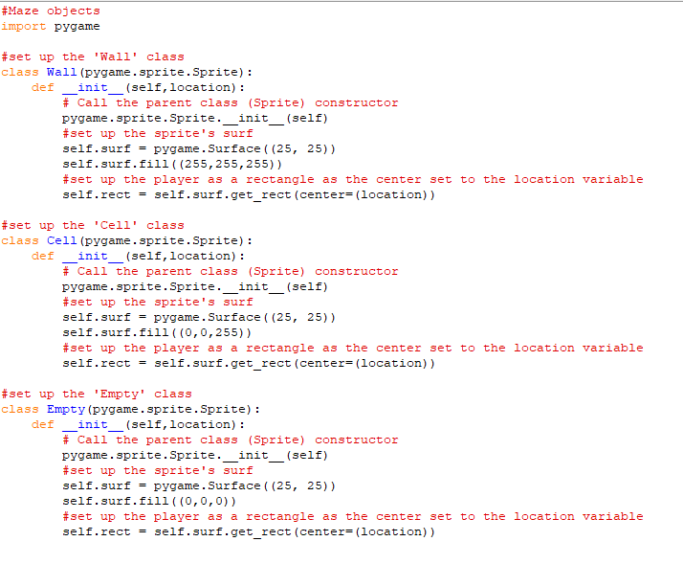

I then decided to make my ‘pygame_window’ class with a ‘display’ method

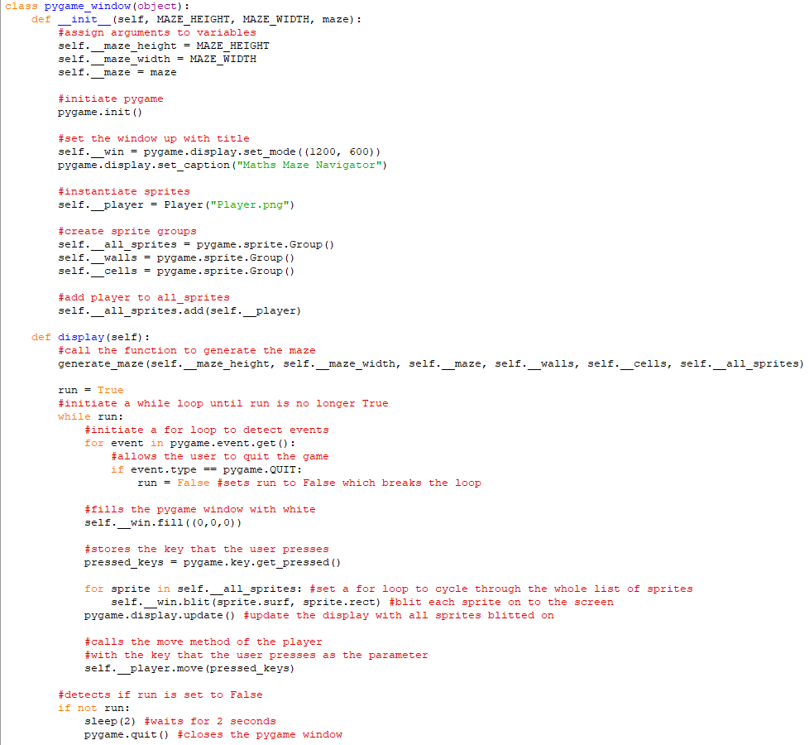

I then decided to use an object oriented approach to update my main program

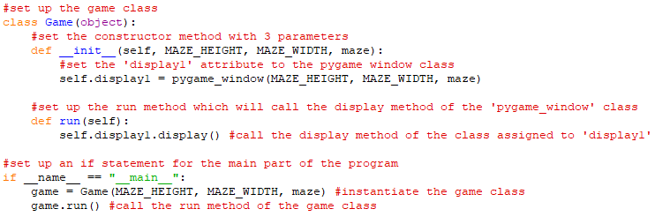

Next I worked on my ‘generate_maze’ procedure

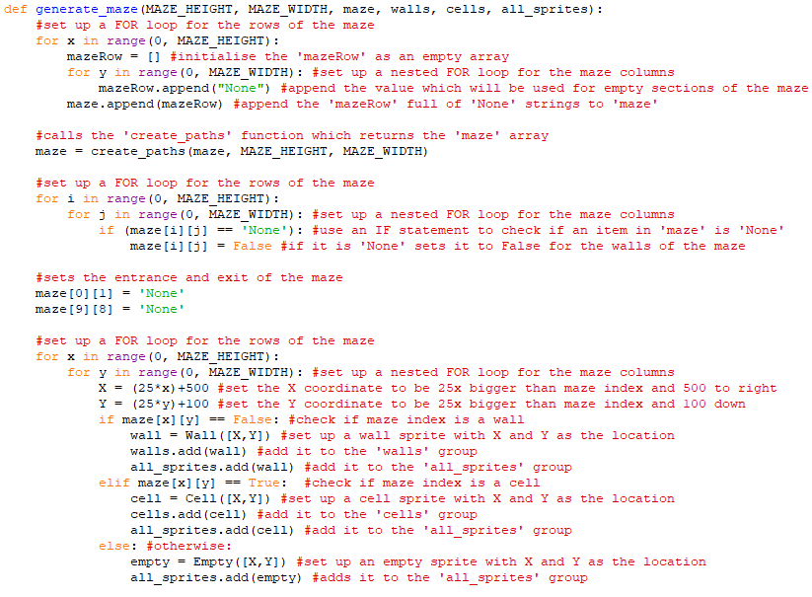

This includes the ‘create_paths’ function which will also return the maze array

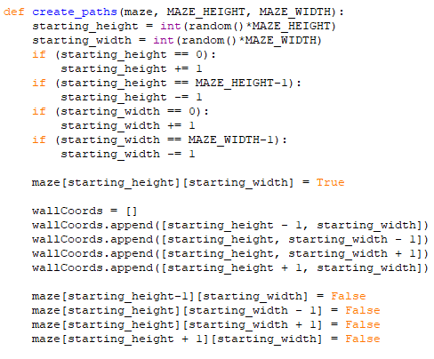

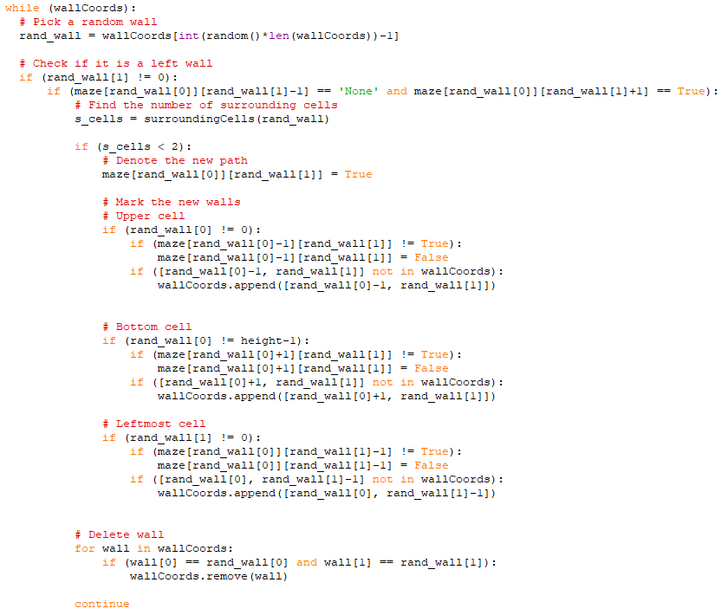

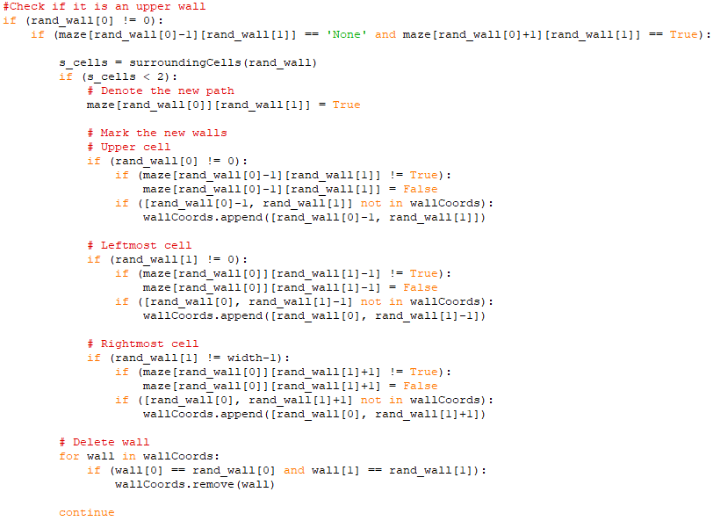

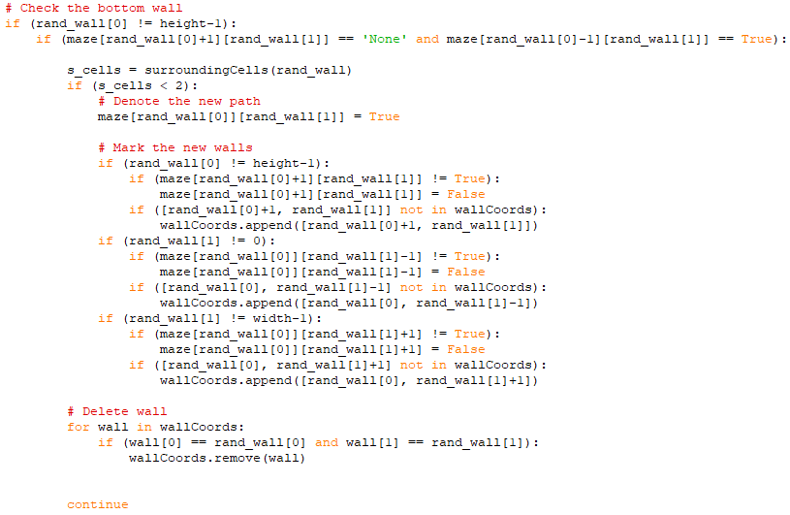

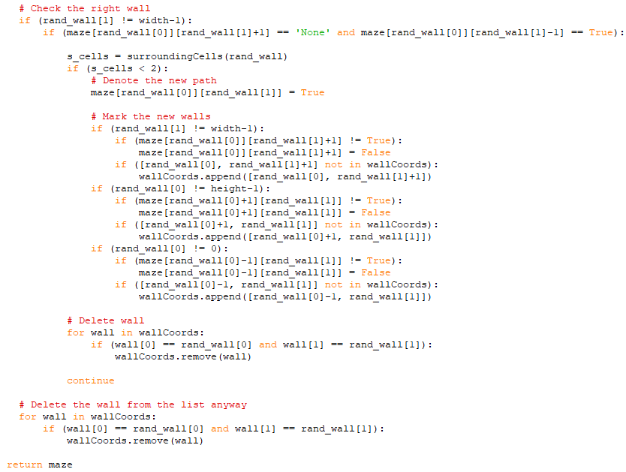

Above is the python implementation of Prim’s algorithm (the above 4 screenshots) which is used within the ‘create_paths’ function. See documented design [page 40] for more info.

Then there were to be some more small little tweaks before it was ready for testing

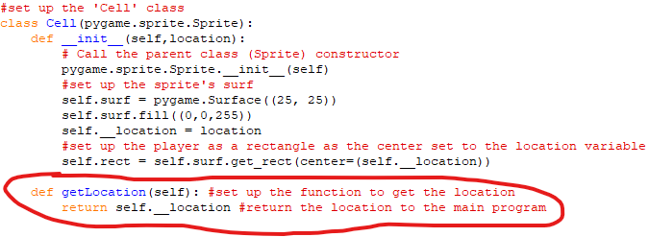

A getLocation method was added to the Cell class

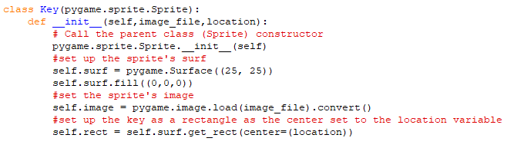

A Key class was added

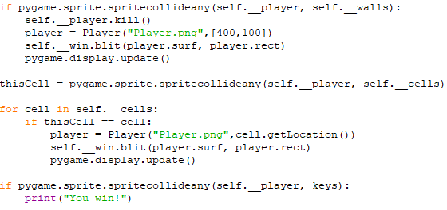

Collision detection with Walls, Cells and Keys was added

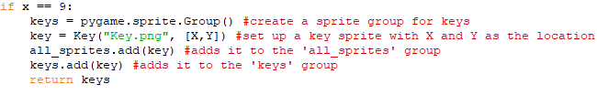

Initialising the key and adding it to 2 sprite groups was added

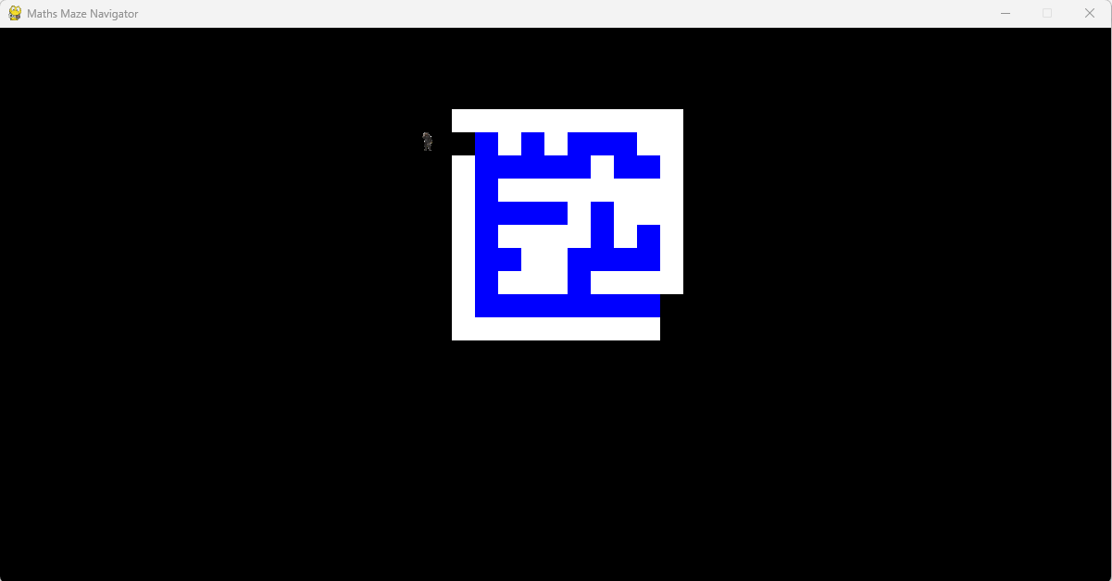

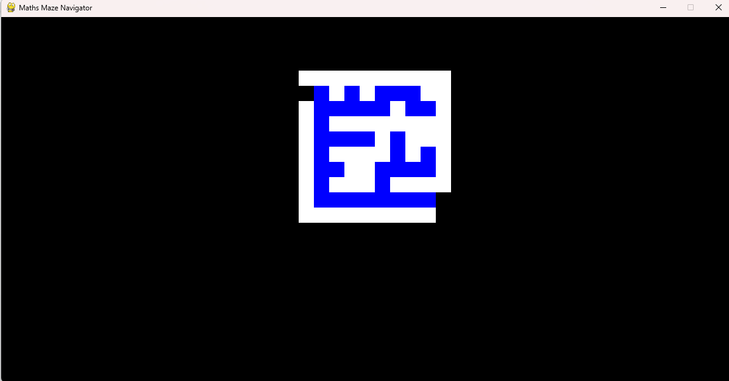

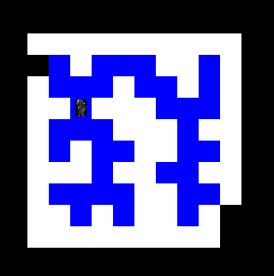

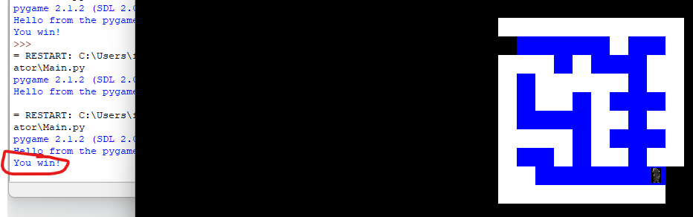

This was phase 1 of the testing and game development

**Phase 2:**

To begin with phase 2 introduced some ‘Information objects’ as part of the game. These include the scoreboard, lives counter, moves counter and timer. Also to be added were a start screen and 2 end screens - one for winning and one for losing.

Firstly I decided to create the Scoreboard class. This was done in a subprogram which also included the lives counter, moves counter and timer classes.

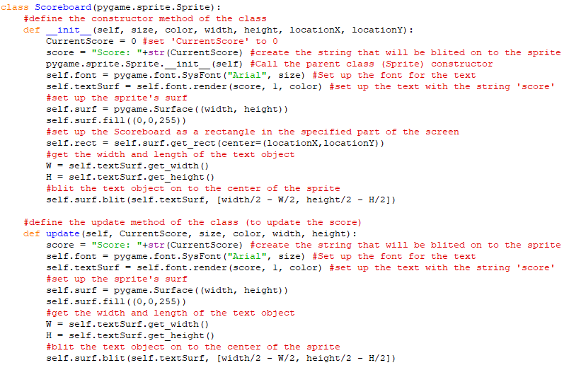

Next I created the Lives counter class - in the same subprogram.

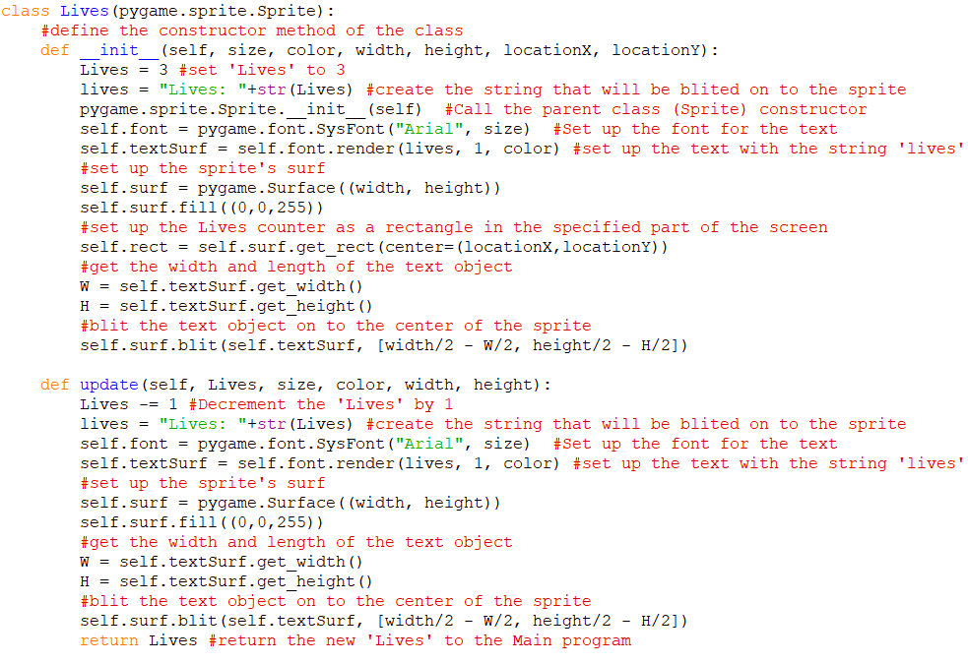

Then I created the Moves counter class - also in the same subprogram.

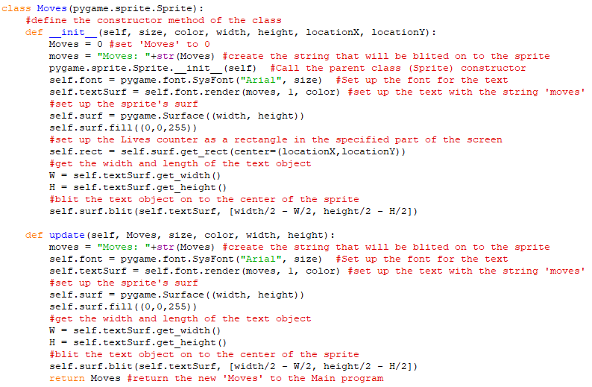

Finally, in the same subprogram, I created the timer class in the similar way to the previous three classes.

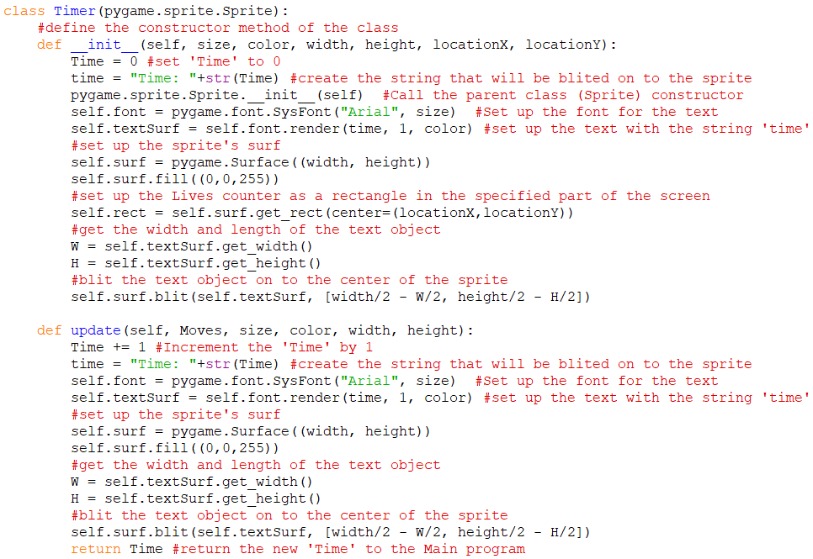

Next the ‘move’ method of the ‘Player’ class was updated

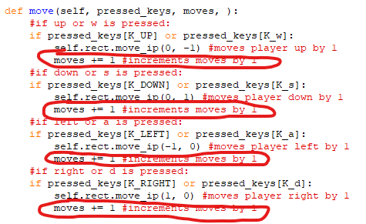

Then the constructor of the pygame window in the Main program was updated to include instantiation of the Scoreboard, Lives counter, Moves counter and Timer.

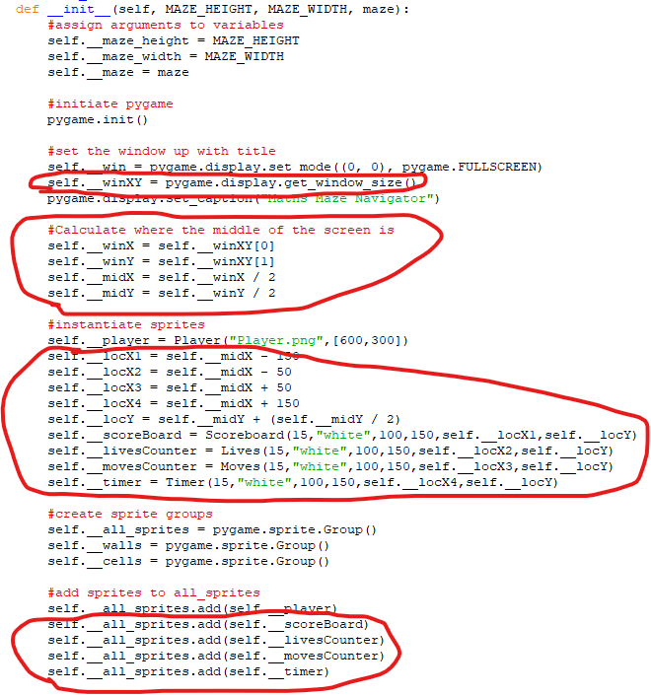

Next I had to include the update methods of the Information objects at appropriate times

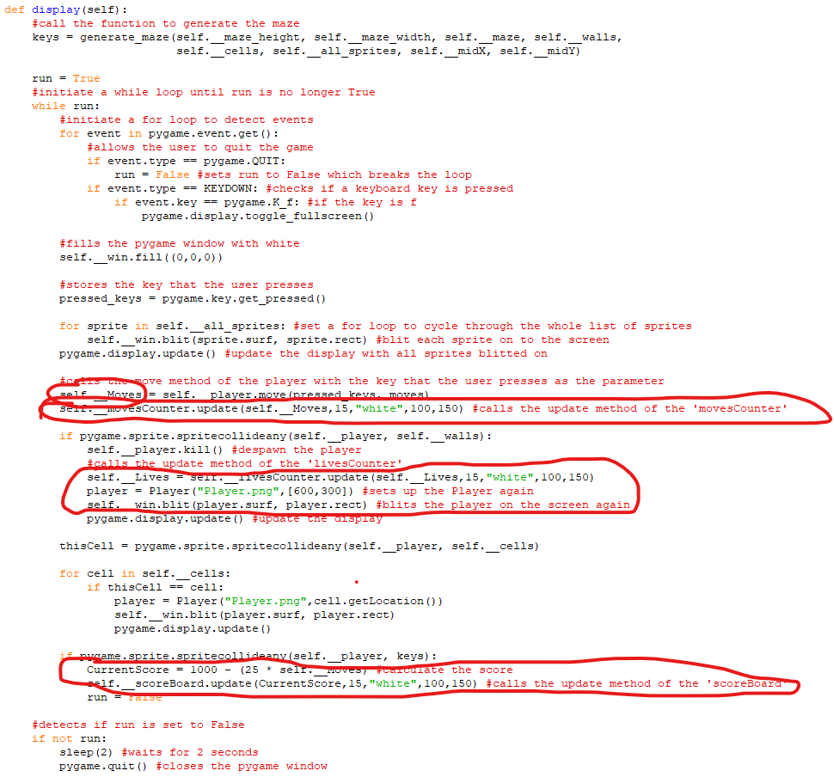

After this, the next stage was to make and call a start screen method to show the start screen. First the objects were made in a subprogram called ‘Starting_objects’

The first class that was made was the ‘Title’ object class

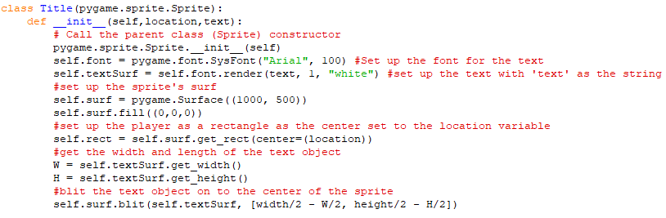

The next 2 classes were the ‘Controls’ and ‘Play’ button classes

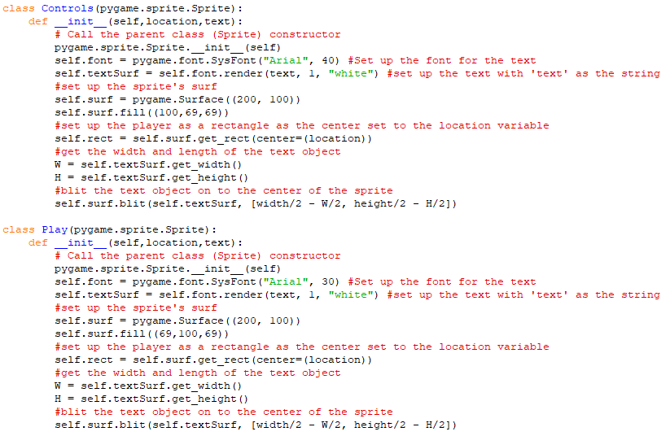

The final 2 classes in this subprogram were the ‘Instructions’ and ‘Quit’ button classes

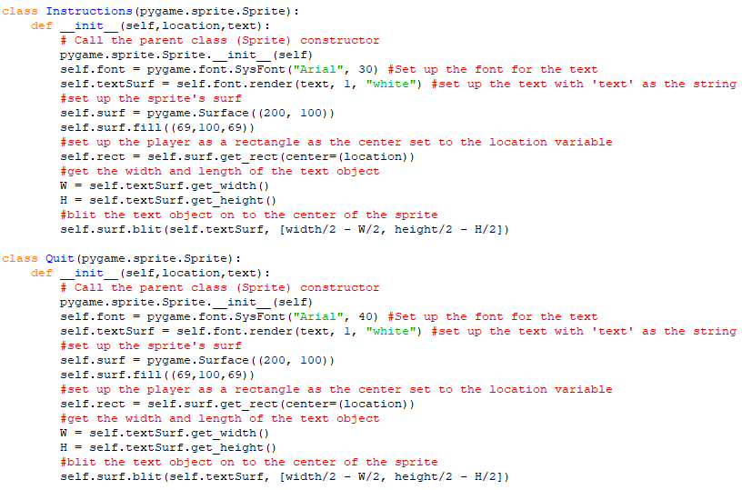

Then the classes for the image sprites for the controls and instructions were made

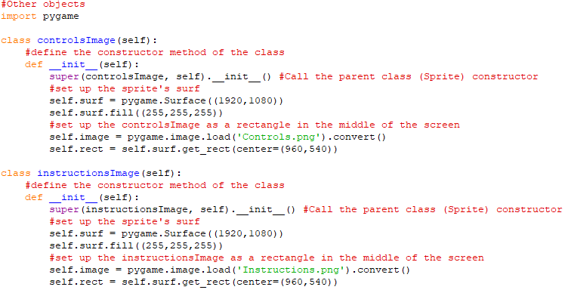

Then the ‘start_screen’ class was made with its constructor method

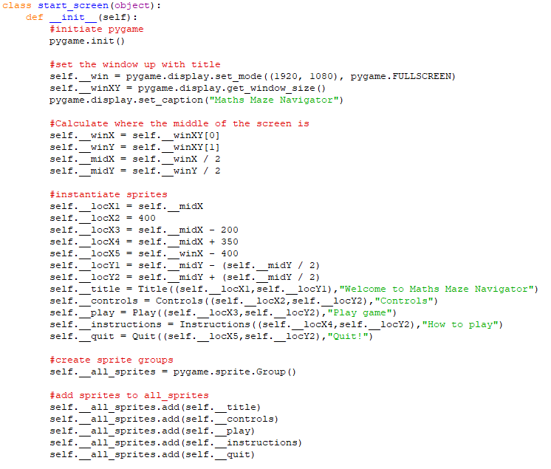

Its ‘display’ method was made

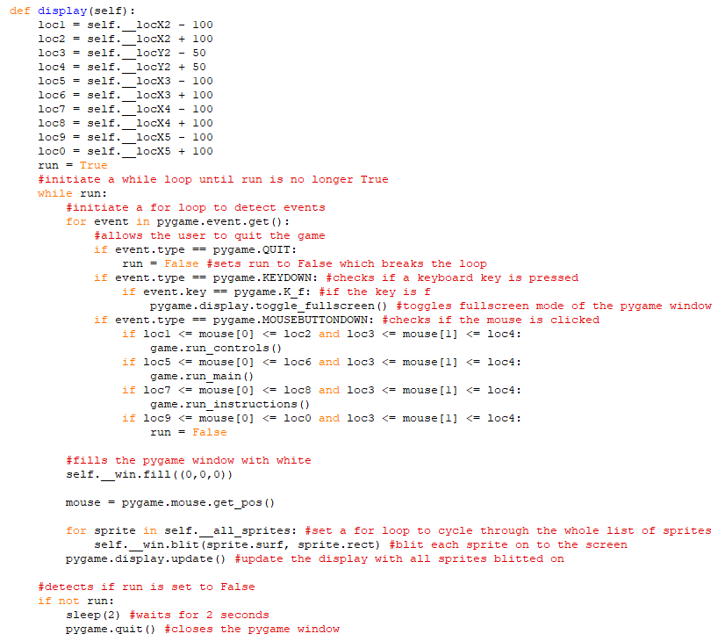

Next the ‘controls_screen’ class was created with its constructor and display methods

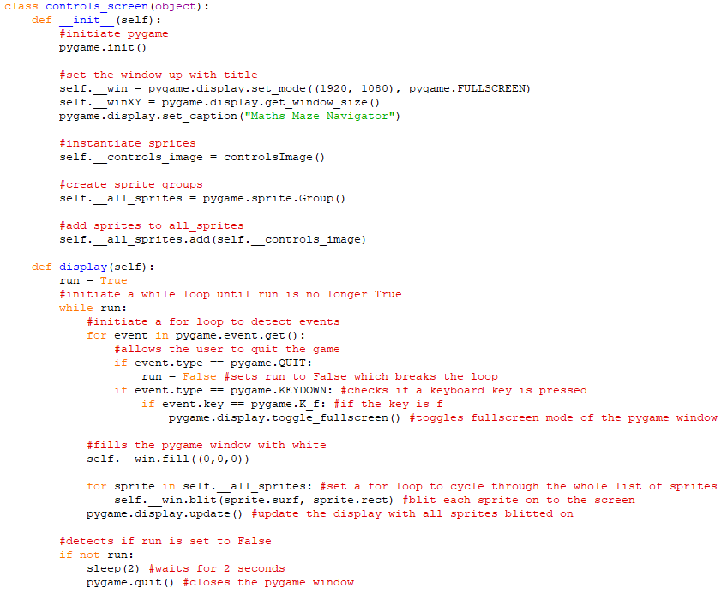

Next the ‘instructions_screen’ class was created with its constructor and display methods

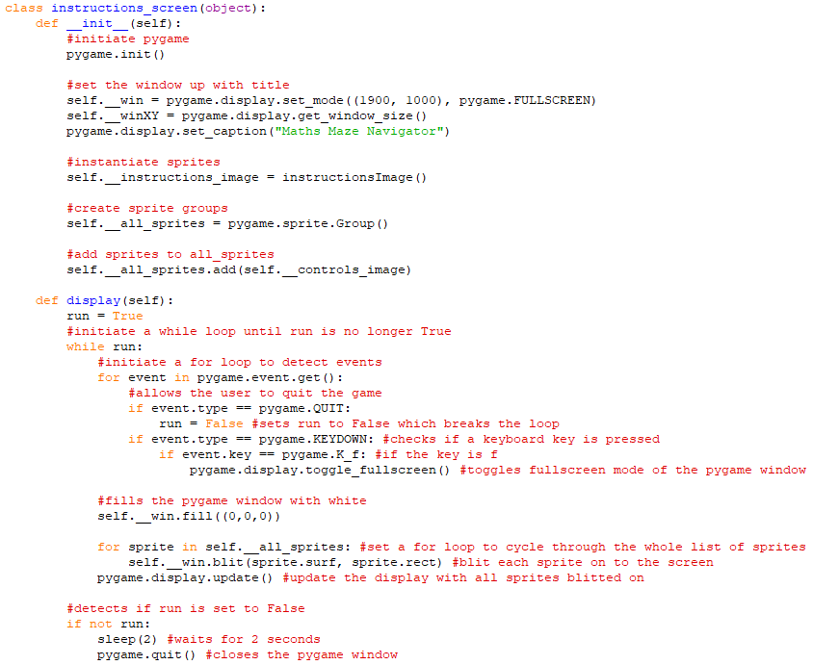

Finally for the start screen, the game class was updated

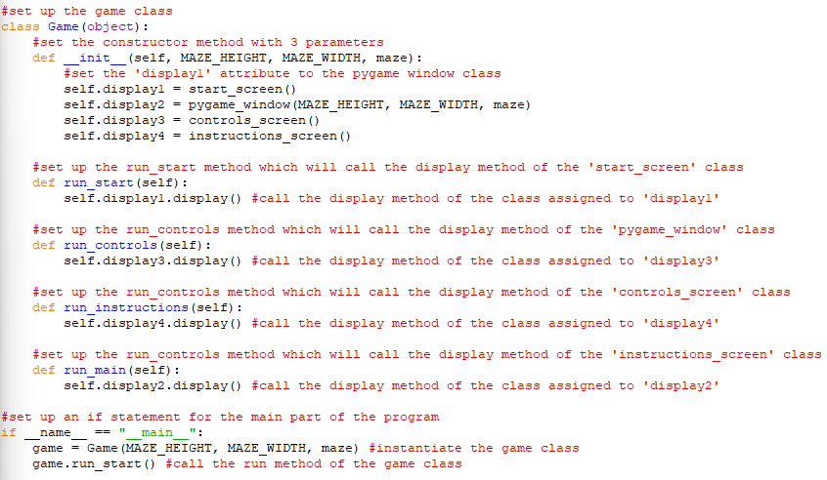

Here are a few screenshots of the program running at this point so far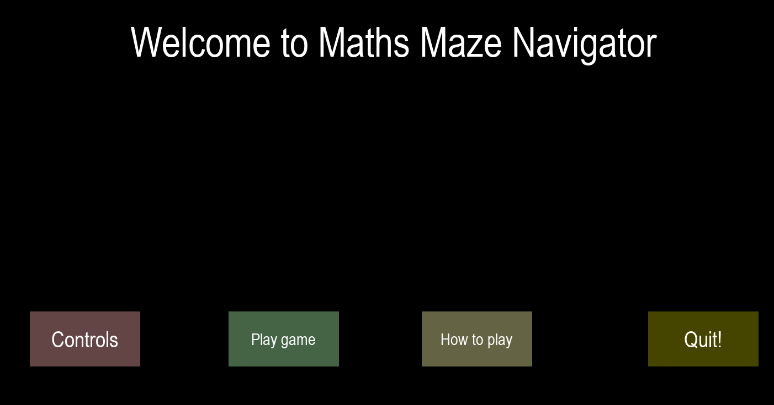

After clicking ‘Controls’: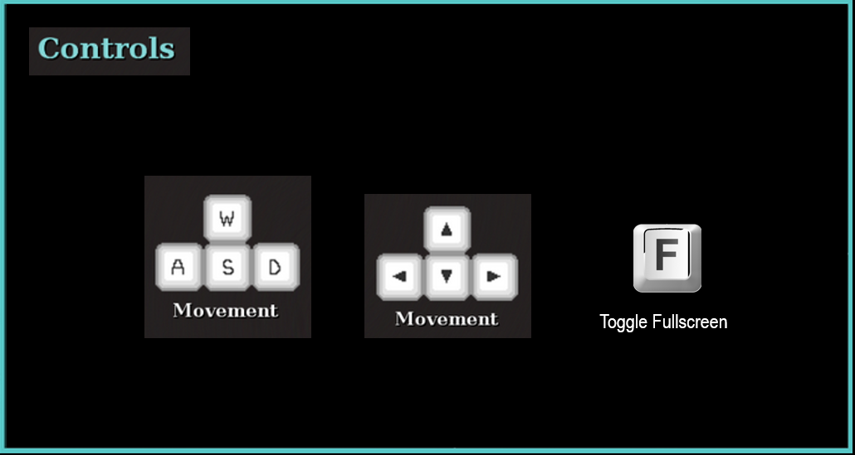

You can also click anywhere to go to the game from the ‘Controls’ or the ‘Instructions screen’

After clicking ‘Play game’:

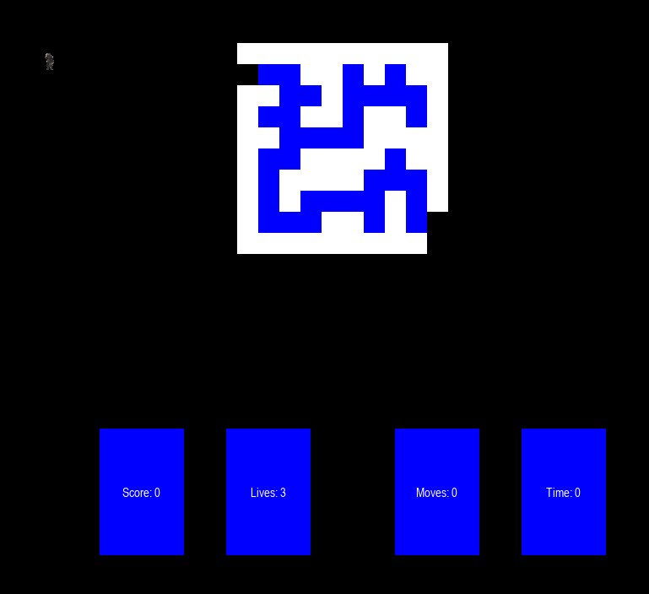After clicking ‘How to play’: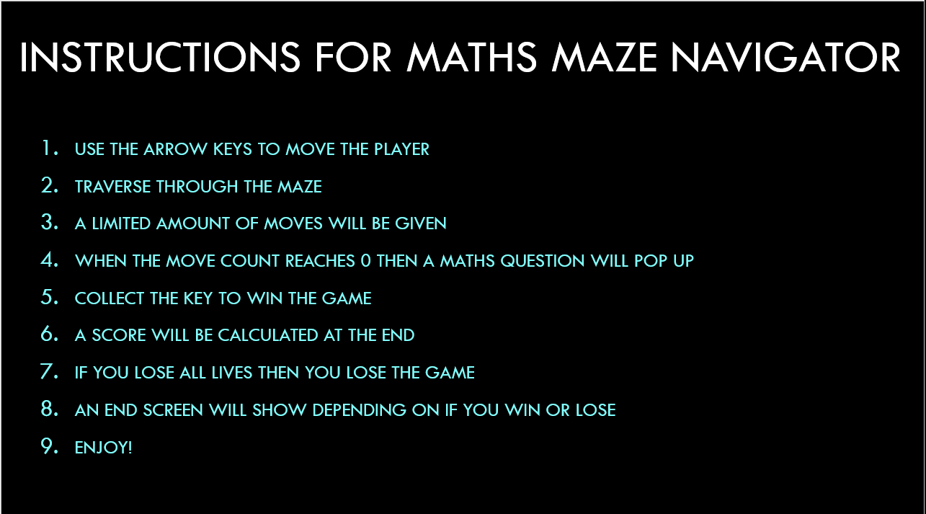

I then added the classes for the win screen and lose screen in the ‘other objects’ subprogram.

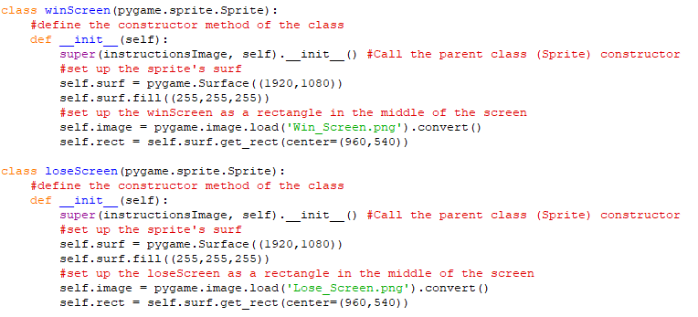

Next the ‘Game’ class was updated to include methods for the win screen and lose screens.

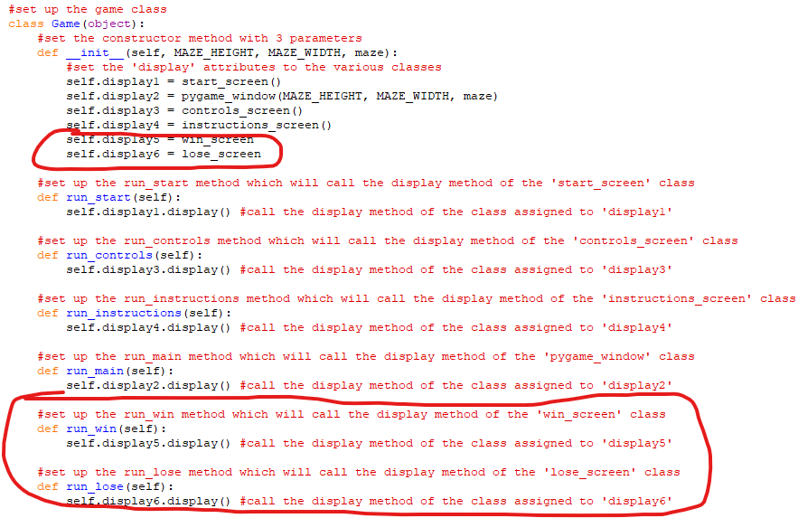

Finally for this phase, the ‘win_screen’ and ‘lose_screen’ classes were created.

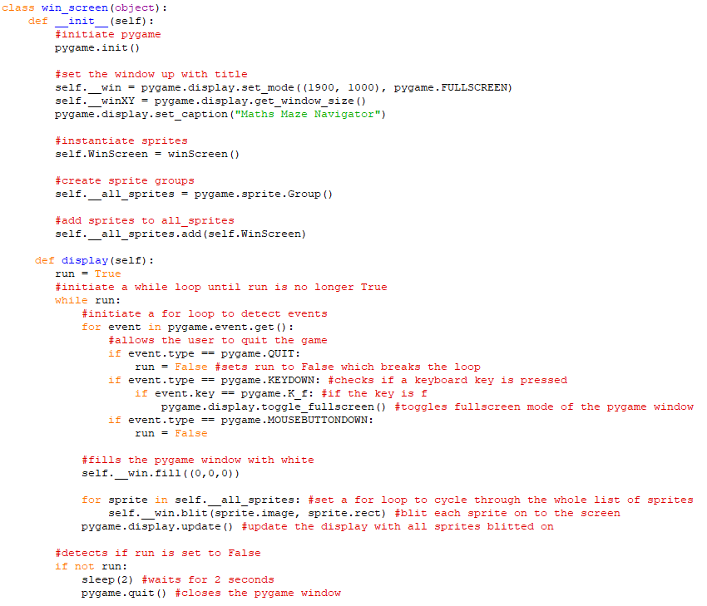

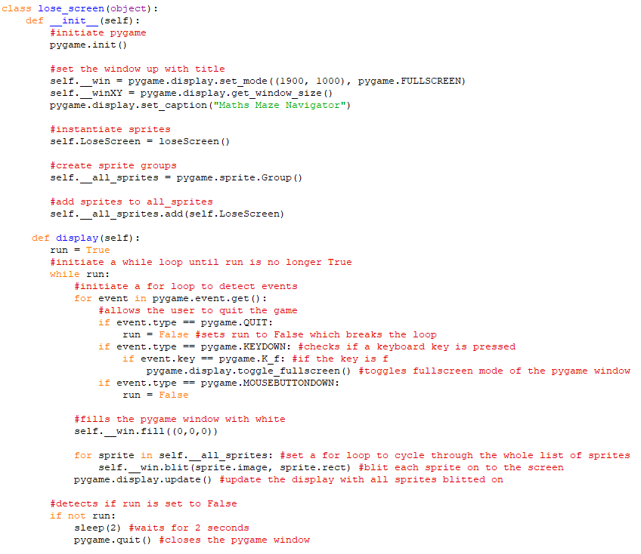

Also the calls of these methods was implemented into the ‘pygame_window’ class

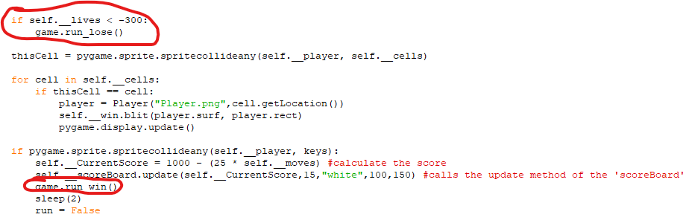



**Phase 3:**

In this phase I created the Maths side of the game using Tkinter and the questions from a file.

Firstly the app class and main part of the program was created

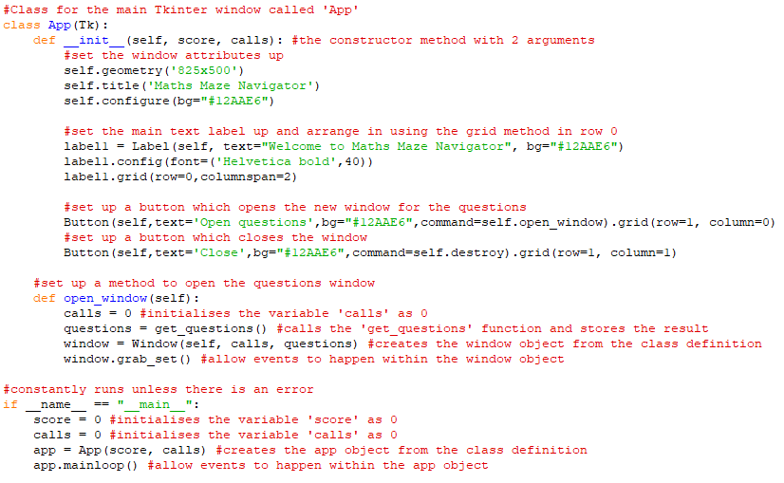

Then the ‘get_questions’ function was created which imports the questions from a file and returns them in a 2D array.

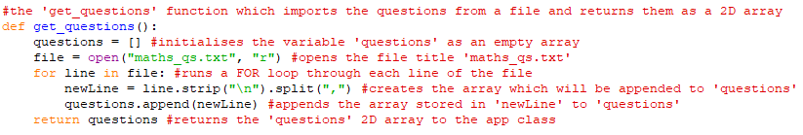

The output of questions can be shown below:

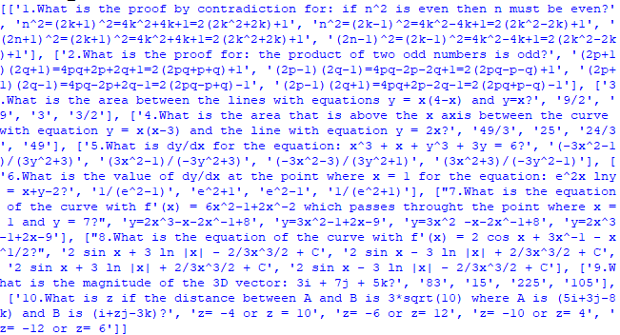

Next the ‘Window’ class was set up which would show the questions, 4 possible answers and allow the user to answer the question. It would also allow the user to go to the next question or close the window.

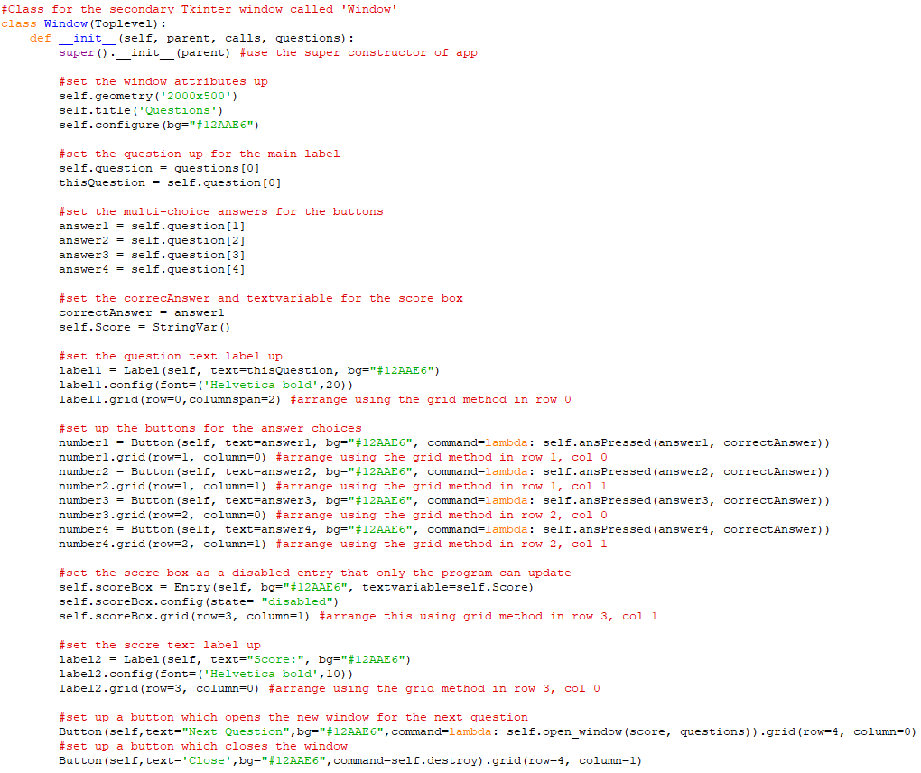

Its method for updating the score when a question was answered was also included.

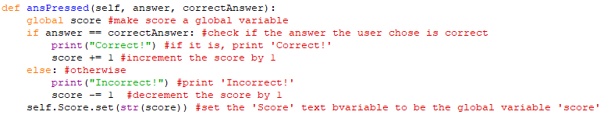

Also its method for opening the next question was included.

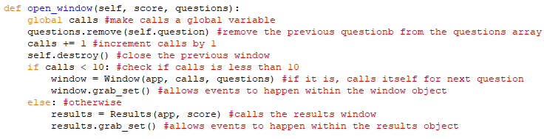

Finally for this phase, the ‘Results’ class was created to show the final results.

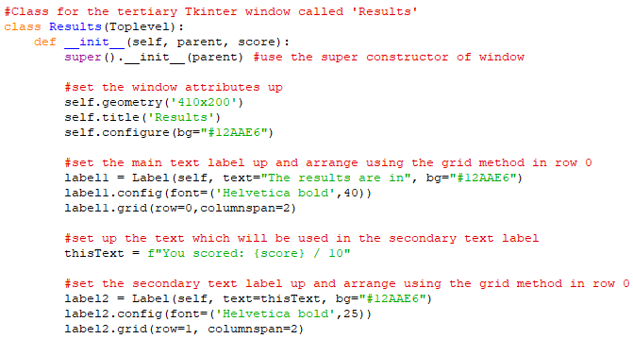

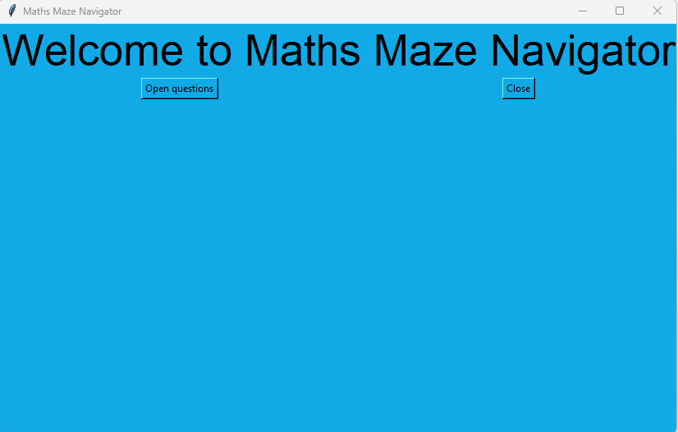

After clicking ‘Open questions’: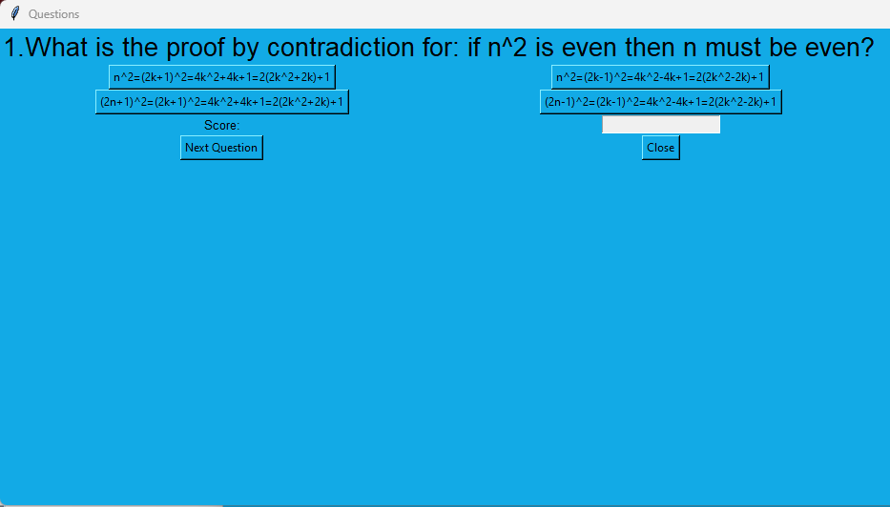

After clicking option 2: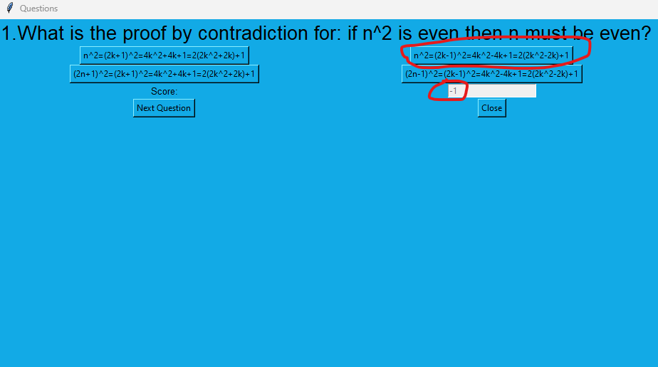

After clicking ‘Next Question’: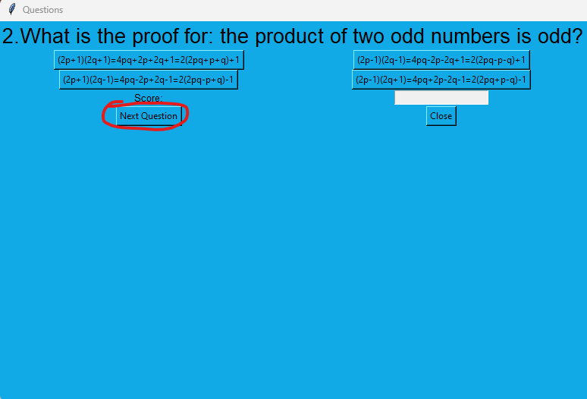

After clicking option 1: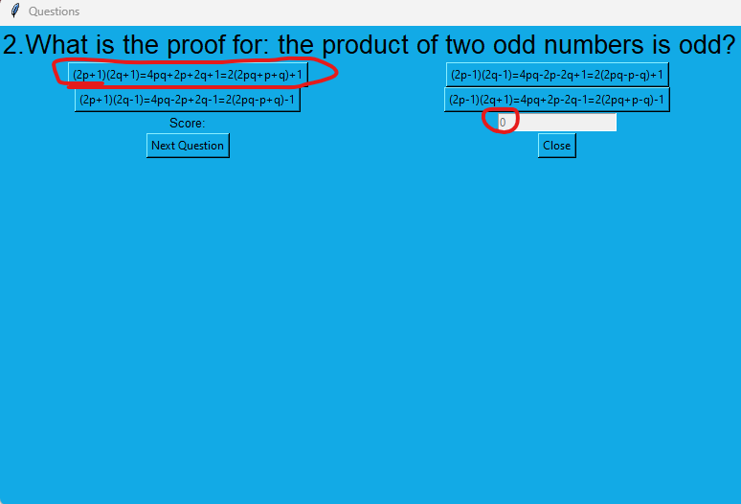

After clicking ‘Next Question’ then option 1:

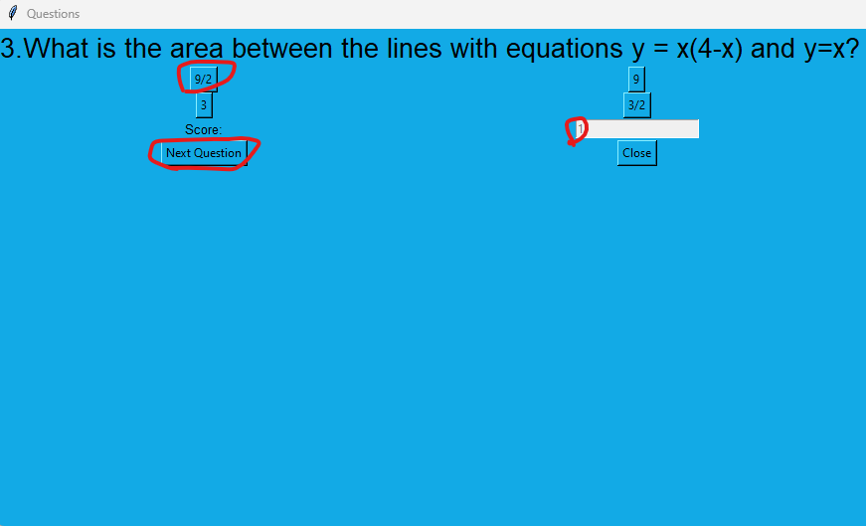

After further clicks of ‘Next Question’ and the correct option:

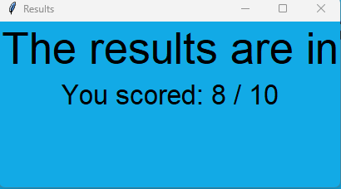

**Phase 4:**

This phase was about improving the code from Phase 2 to include a save and load game buttons and more features. It also introduced a high scores system.

Firstly, the timer class was implemented properly so the timer updates every second.

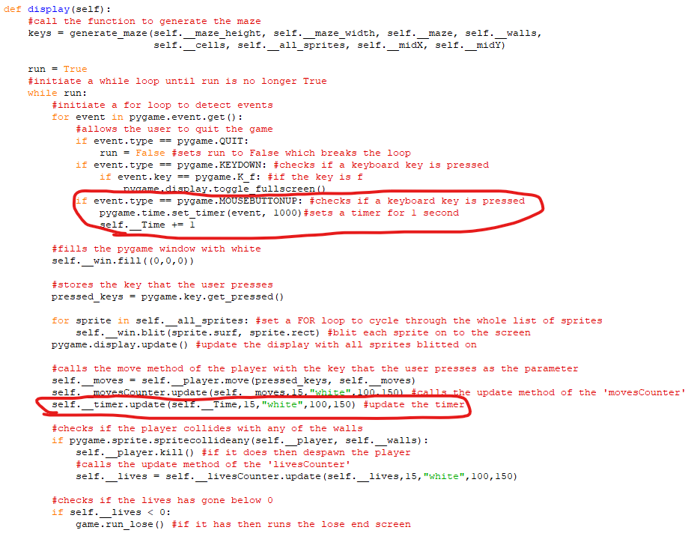

Next, the screens interface was added which was currently the base class for the 6 screen classes which were start_screen, pygame_window, controls_screen, instructions_screen win_screen(), lose_screen()

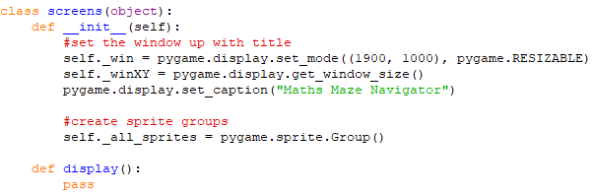

The next thing to do was to start making the save/load game feature.

Firstly, the ‘GameSave’ class was made in a new subprogram with 3 methods.

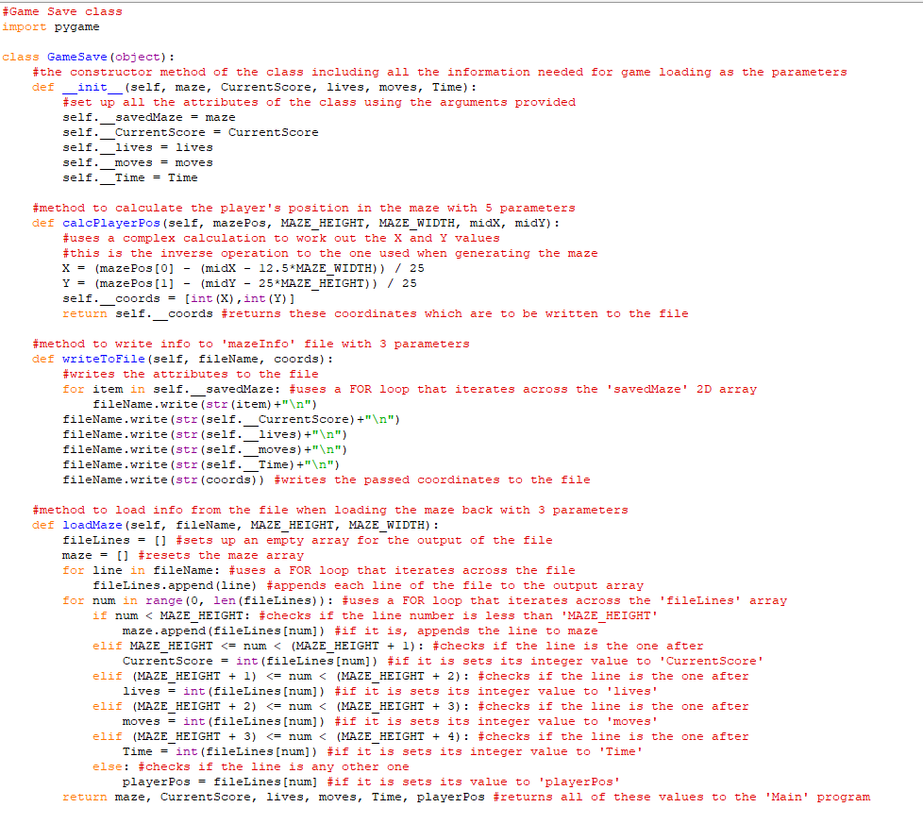

Also, a visited 2D array was added to show the squares in the maze that the player has visited.

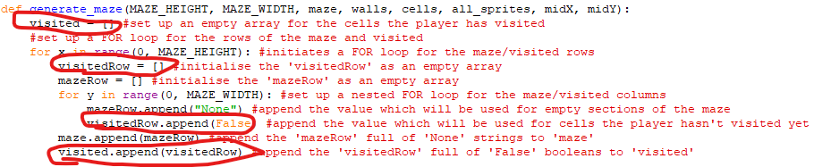

Next, a SaveButton and LoadButton classes were added in the ‘Information_objects’ subprogram.

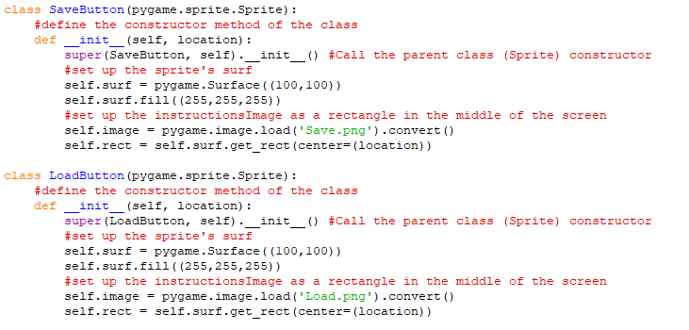

Here is the game with the Save Button and Load Button displayed.

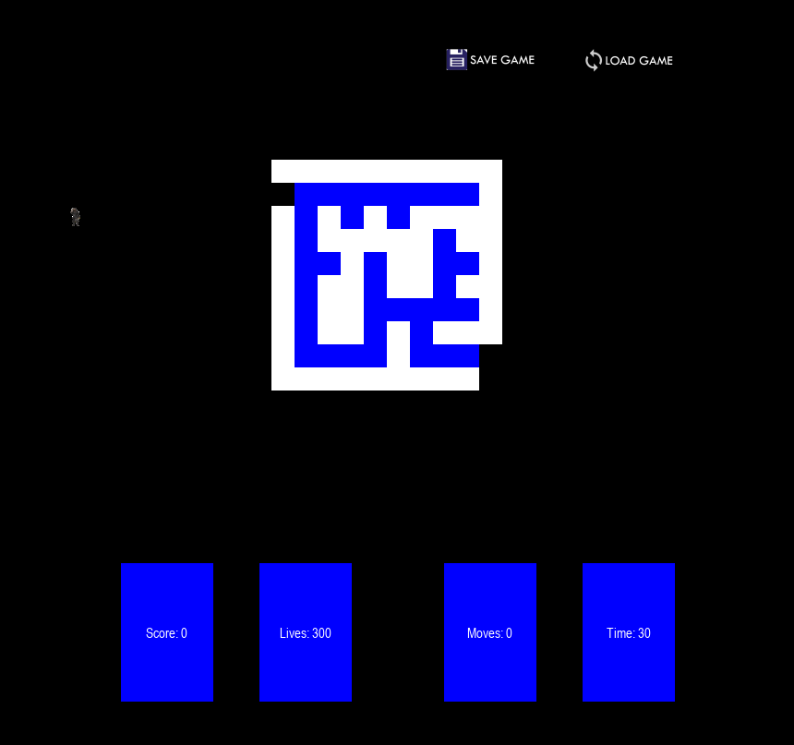

The sprites for the MoveButton and LoadButton were initialised and blitted on to the screen.

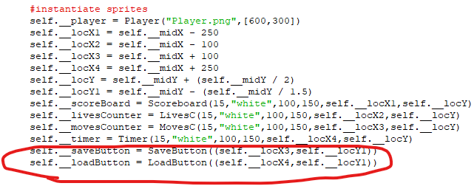

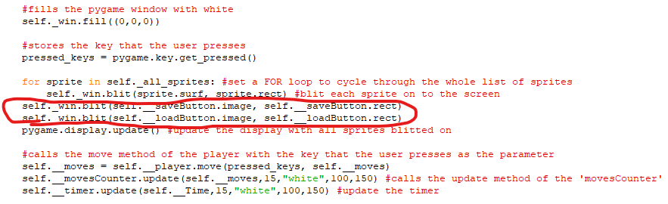

The ‘SS_image’ and ‘LS_image’ classes were set up in the ‘Other_objects’ subprogram.

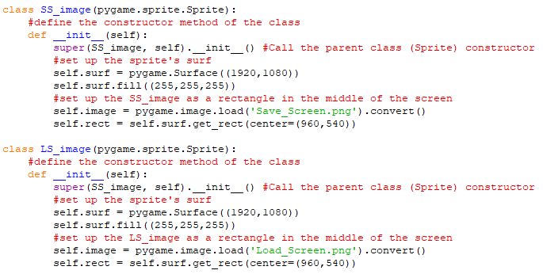

Then, in the ‘Main’ program a ‘save_screen’ class was created with ‘display’ and ‘save’ methods.

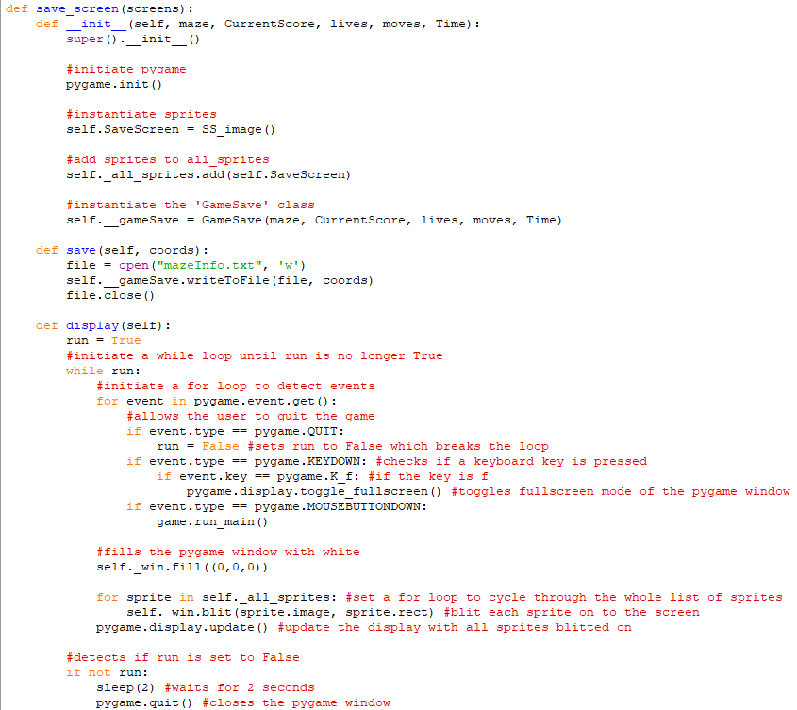

Also a ‘load_screen’ class was created with ‘display’, ‘load_maze‘ and ‘load_game’ methods.

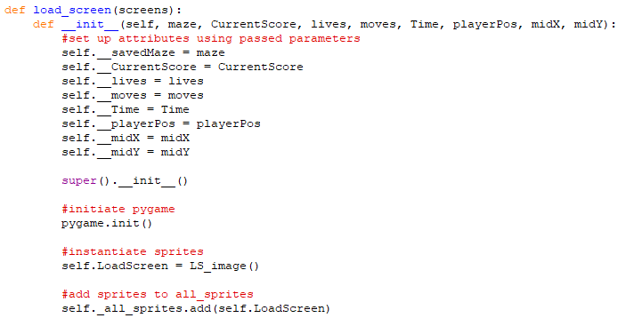

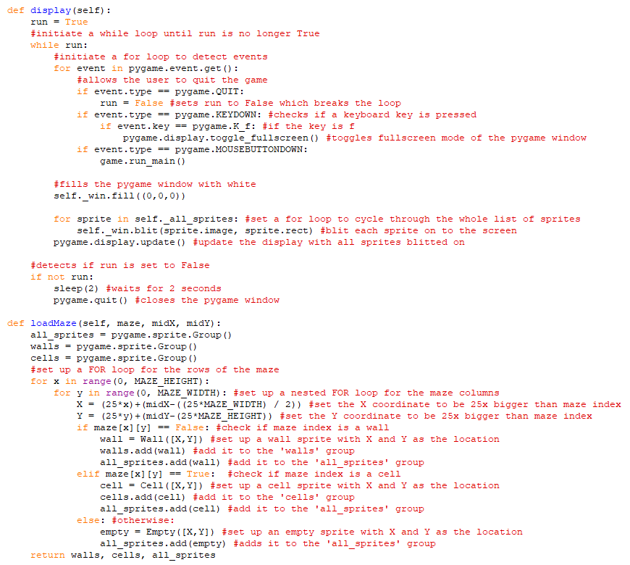

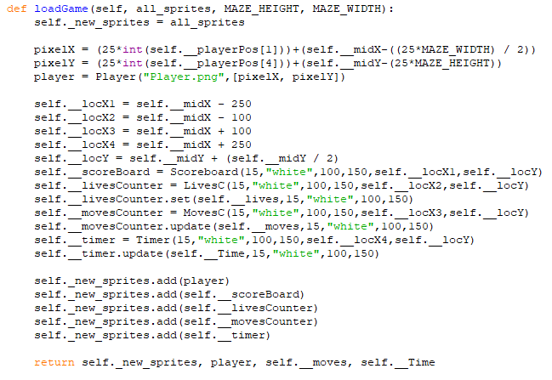

The ‘pygame_window’ class was updated

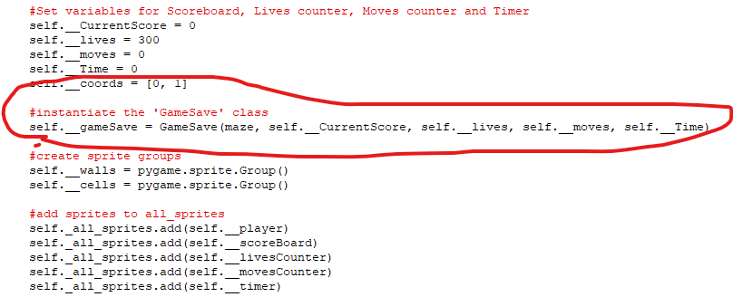

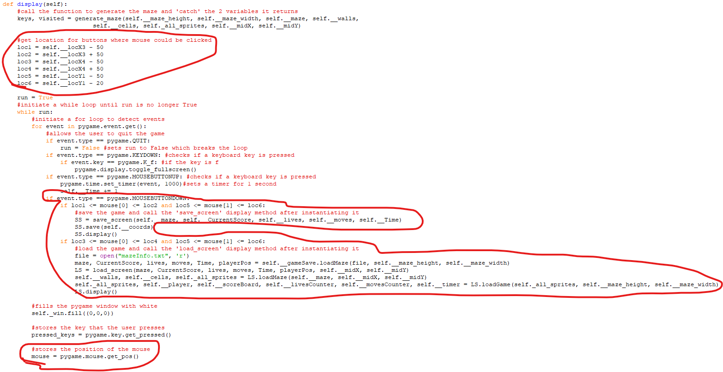

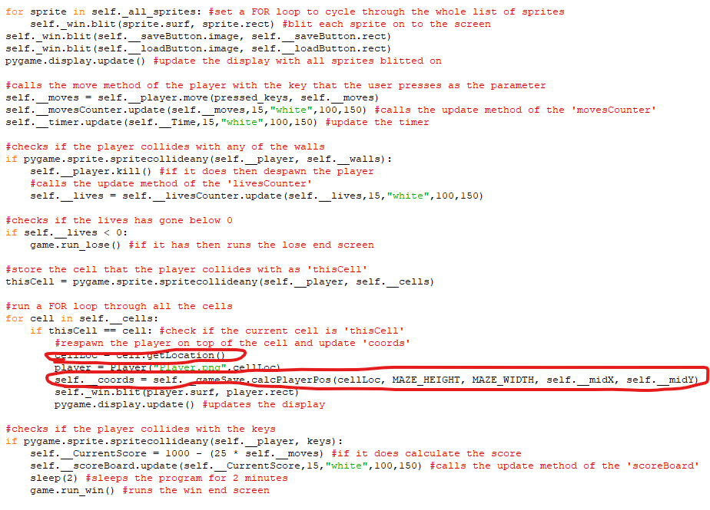

After clicking ‘Save Game’:



The contents of the ‘Maze_Info’ file:

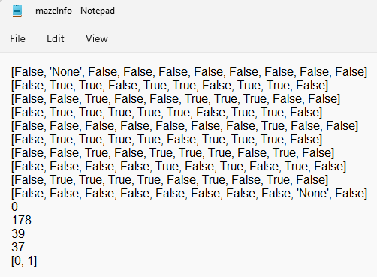

After clicking ‘Load Game’ (after running the game again):

The game after loading: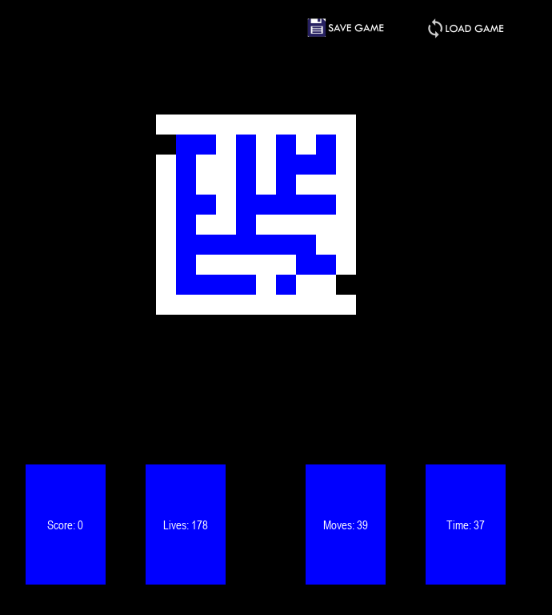

Next, for this phase of the program, the High scores system was implemented.

The ‘HighScores’ class was created in a new subprogram with 6 methods.

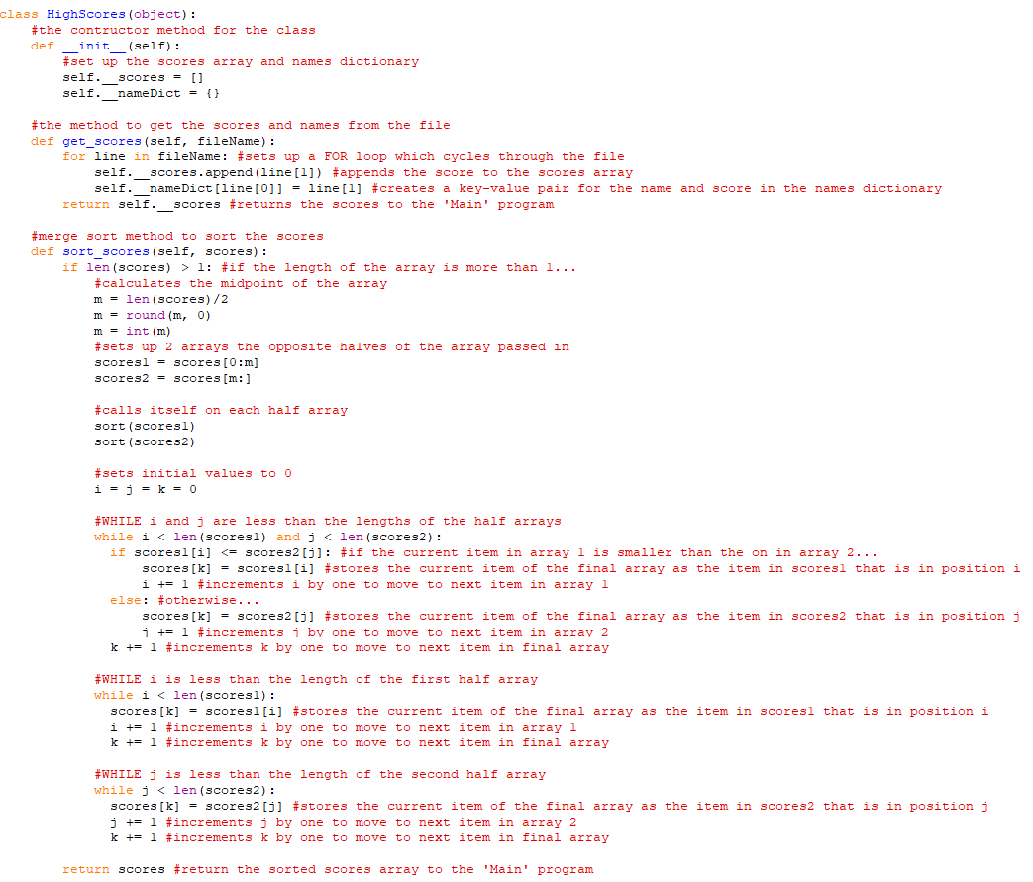

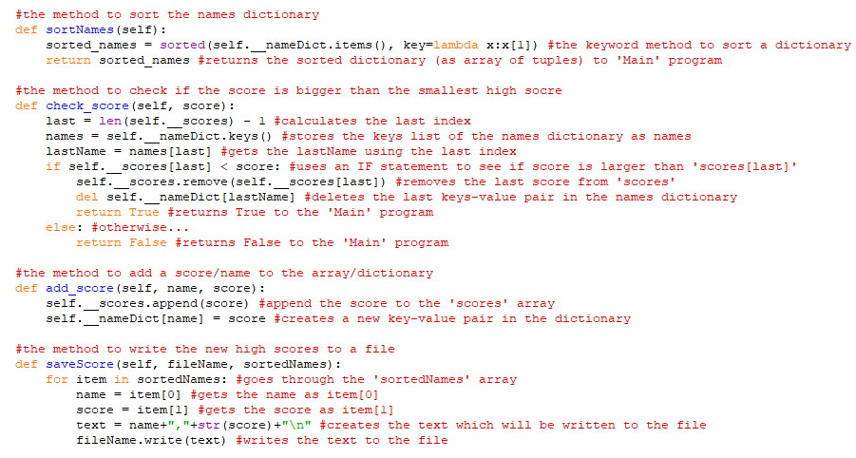

The display method of ‘win_screen’ was updated

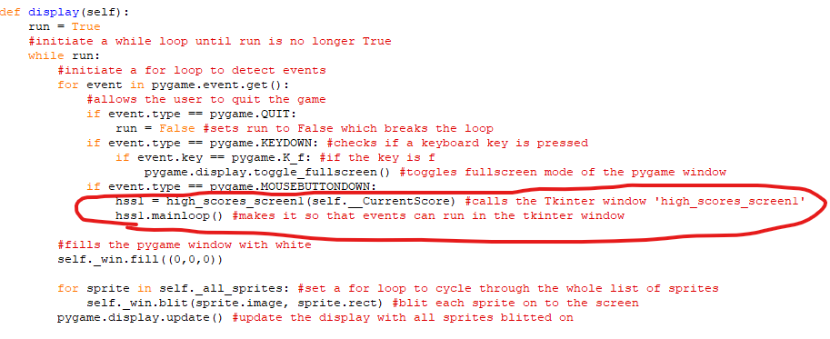

The ‘high_scores_screen’ classes were created

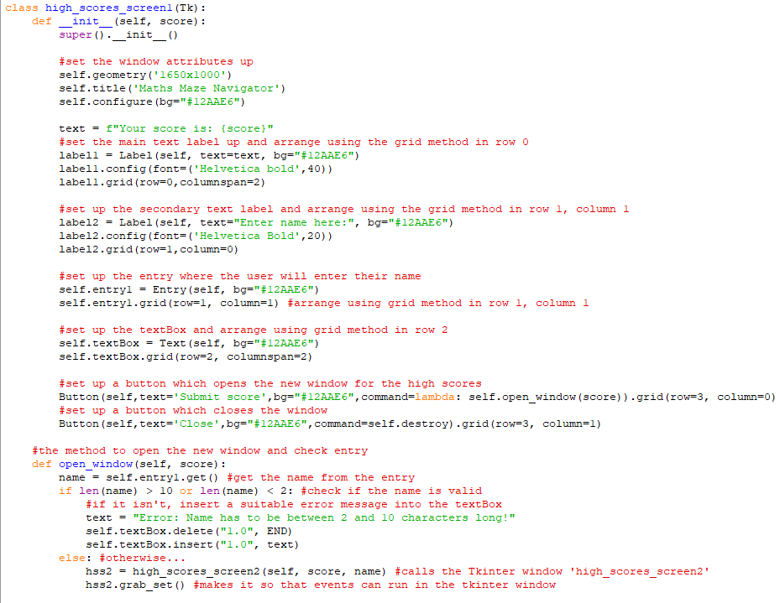

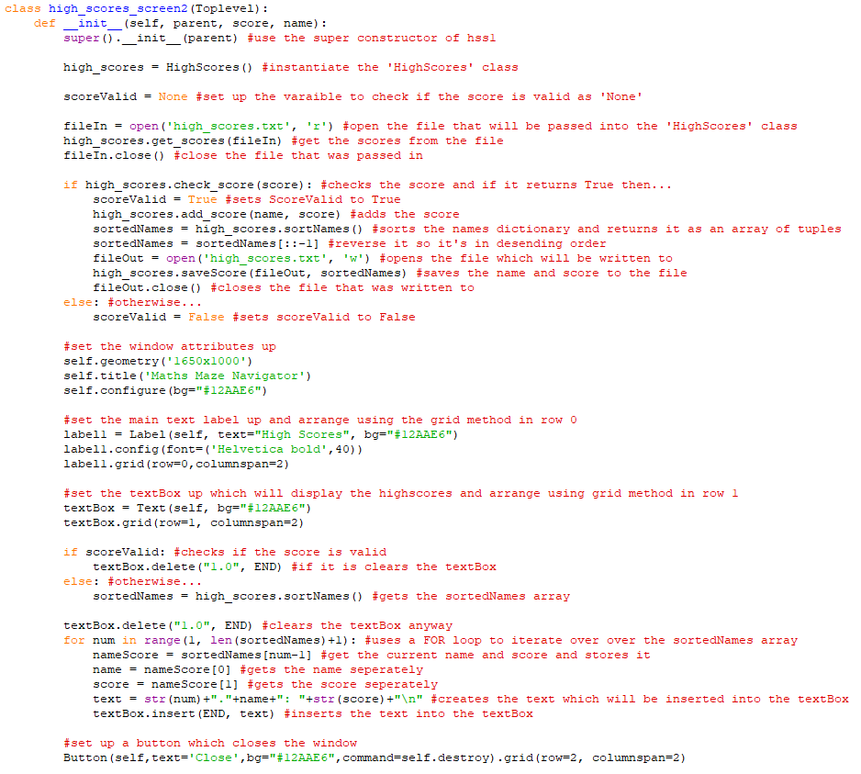

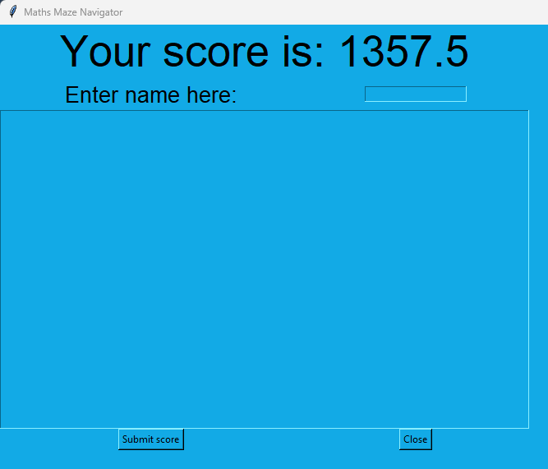

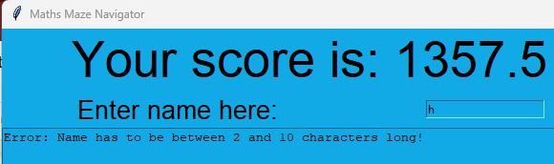

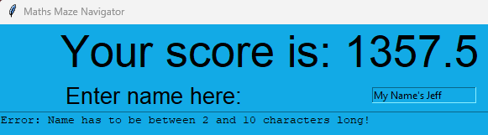

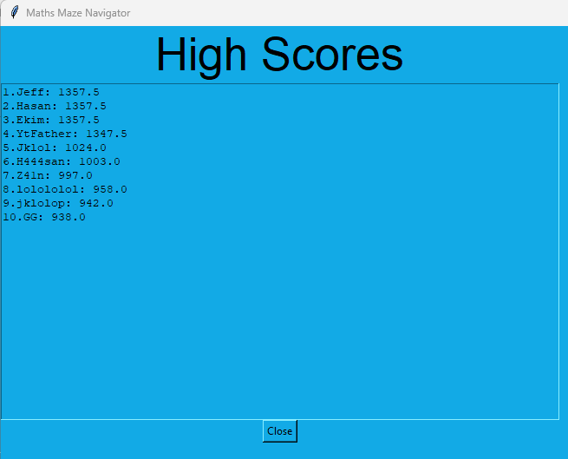

**Phase 5:**

This phase was all about bringing the Maths side of the program (developed in phase 3) and the Maze side of the program (developed in phase 1, 2 and 4) together to form somewhat of a finished product.

To begin with, the buttons for the questions selection screen were made in a new subprogram called ‘QS_objects’. These would decide the type of questions the user would get asked during the game.

Firstly, the ‘Text’ class and ‘Button1’ class were made in ‘QS_objects’

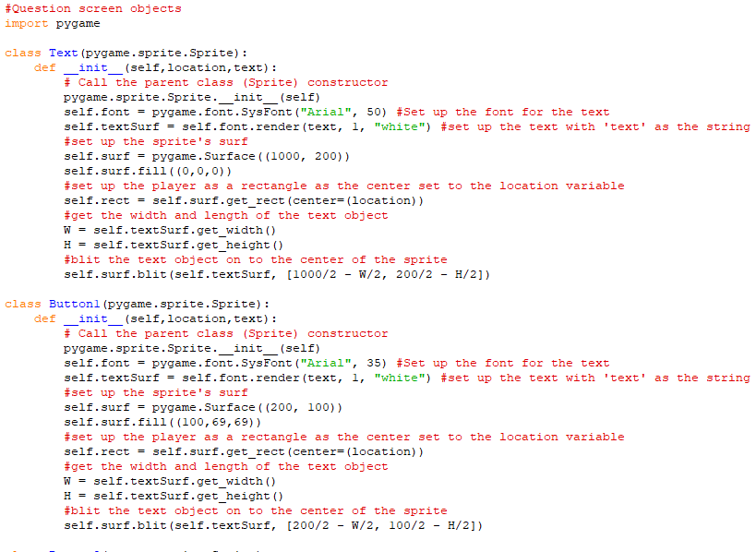

Then the following button classes were made from ‘Button2’ up to ‘Button5’

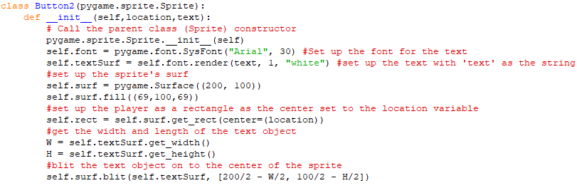

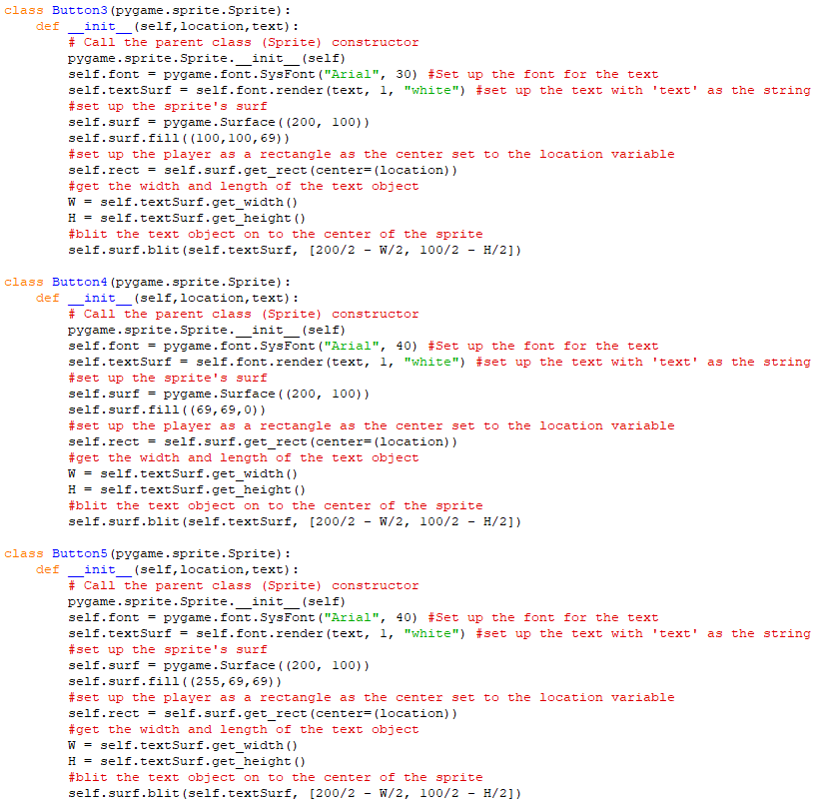

These were then to be instantiated in a new class called ‘QuestionSelect_screen’ which would also inherit from the ‘screens’ class and be part of the ‘Main’ program.

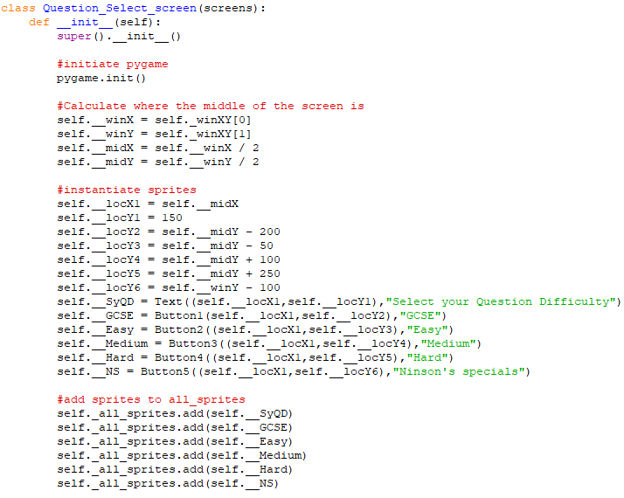

Its ‘display’ method was only included

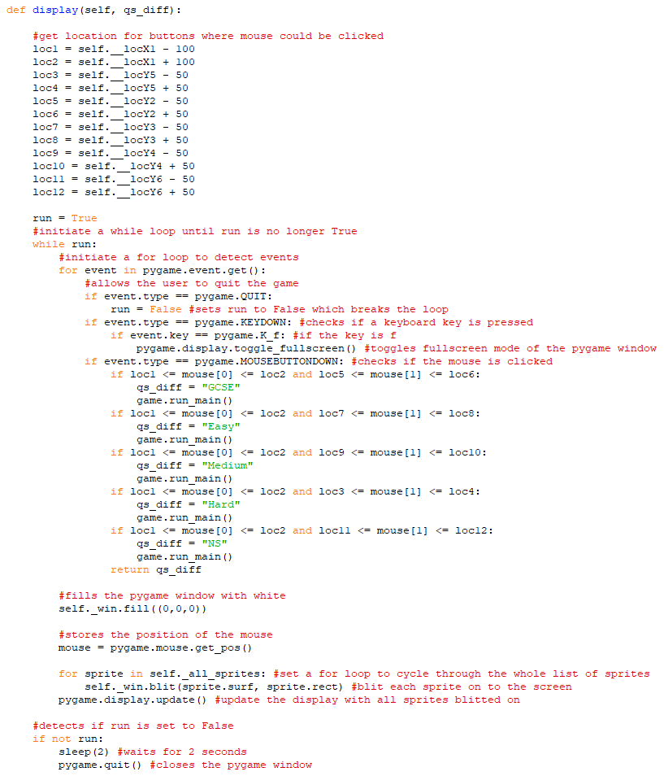

Next, a ‘run_qss’ method was made for it in ‘Game’





Also the ‘display’ method of ‘start_screen’ was updated

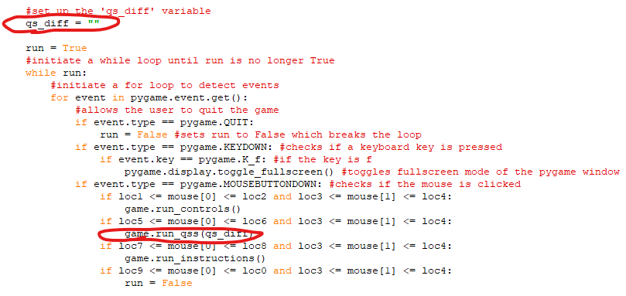

This produced the following screen after pressing ‘Play game’ on the start screen

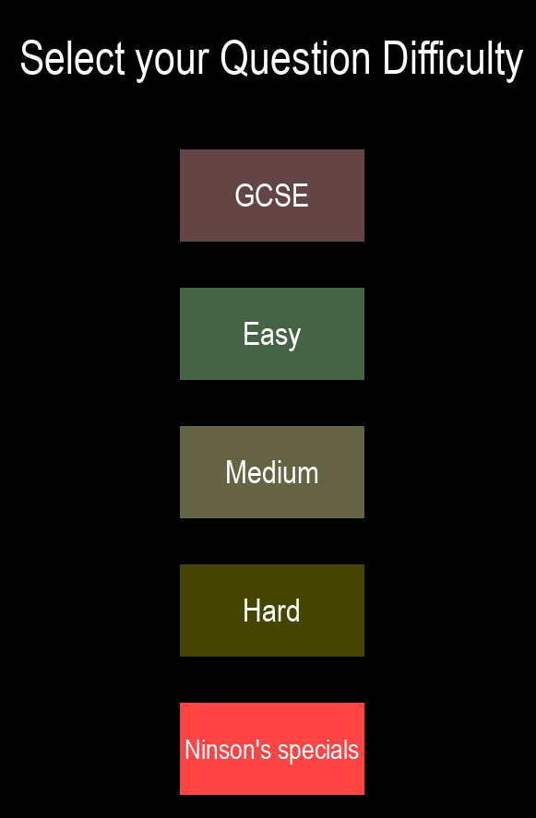

The next thing to do was to combine the ‘Maths_quiz’ and ‘Main’ programs

First the ‘Game’ class was updated

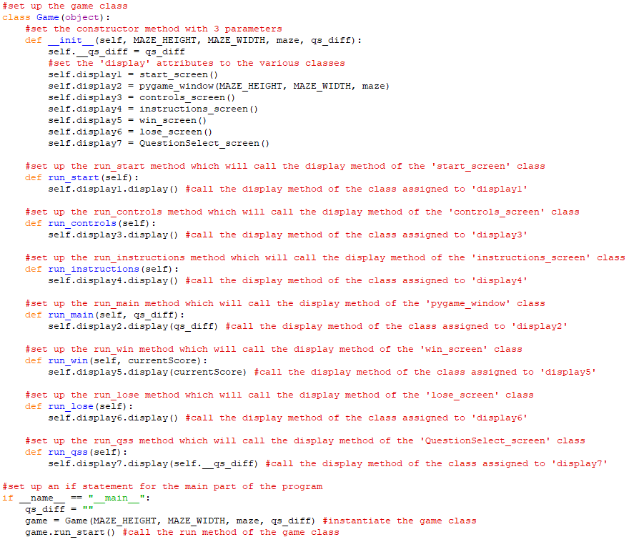

Then a ‘get_questions’ function was defined similar to the one in ‘Maths_quiz’

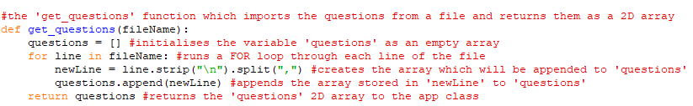

Also an ‘open_question’ method was defined in the ‘pygame_window’ class

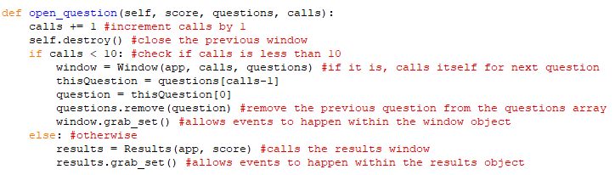

Then, the ‘display’ method of the ‘pygame_window’ was updated to include calling of this new method

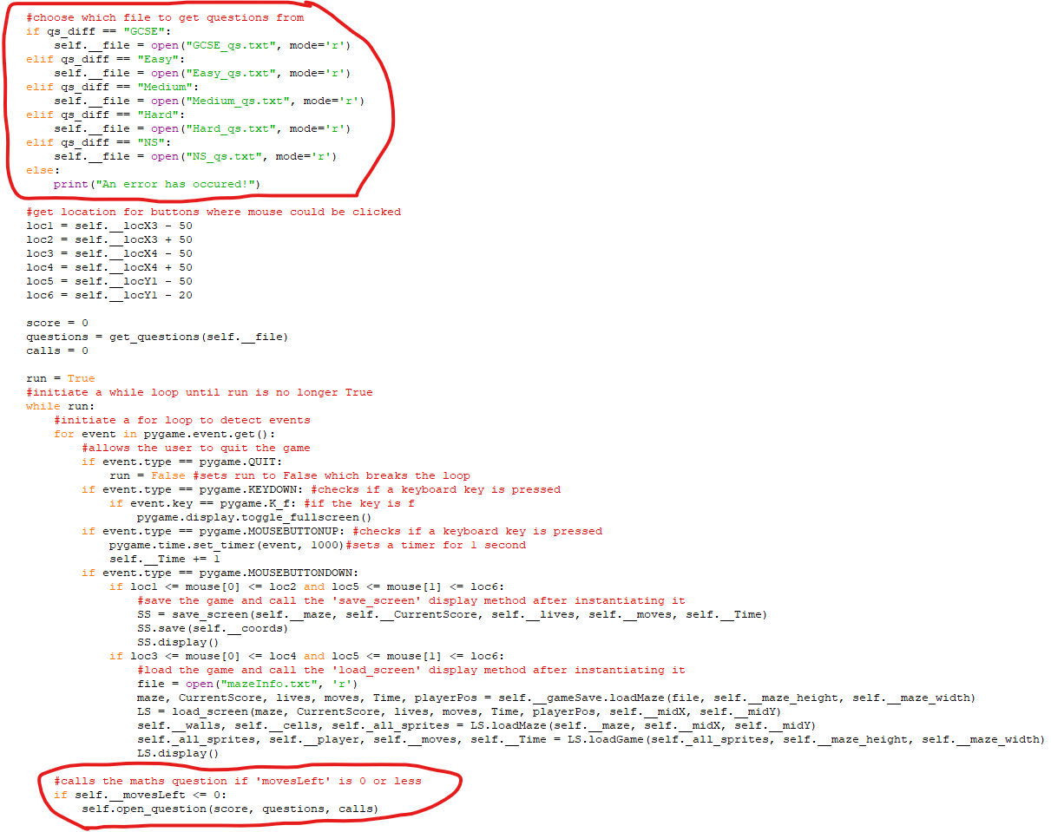

The ‘window’ class from ‘Maths_quiz’ was copied into ‘Main’ and updated as ‘QuestionWindow’

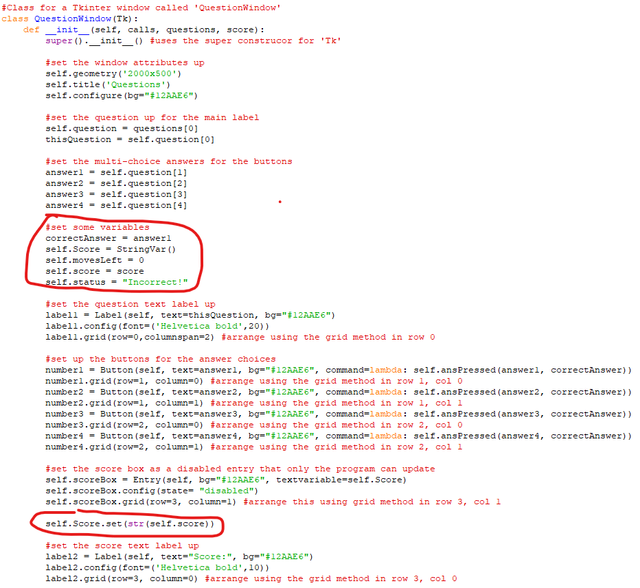

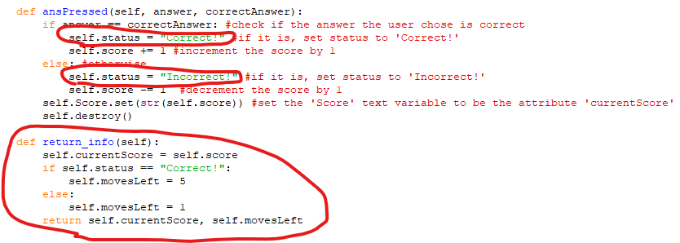

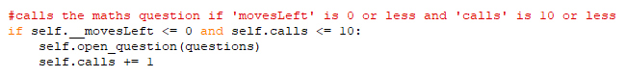

After clicking ‘More Info’ after ‘High Scores’ have opened

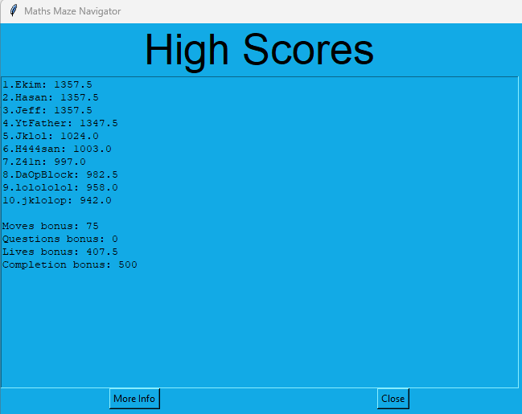

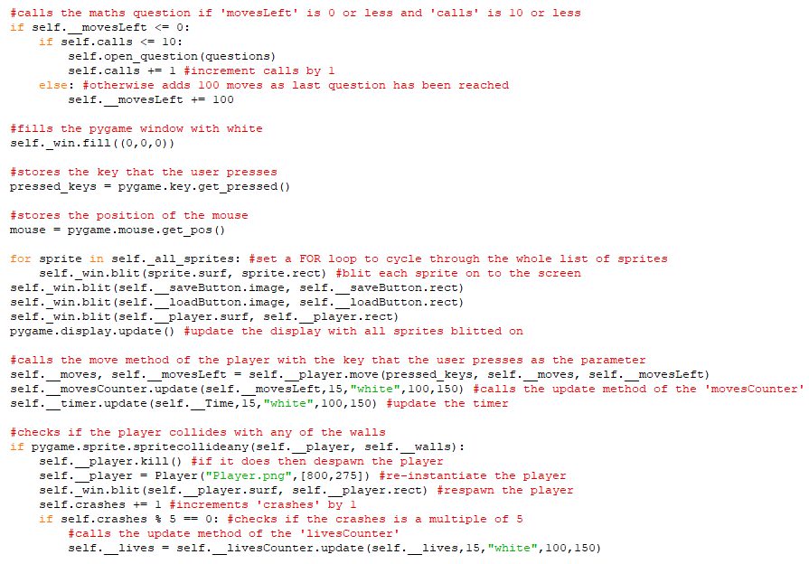

The game after the first question has been displayed

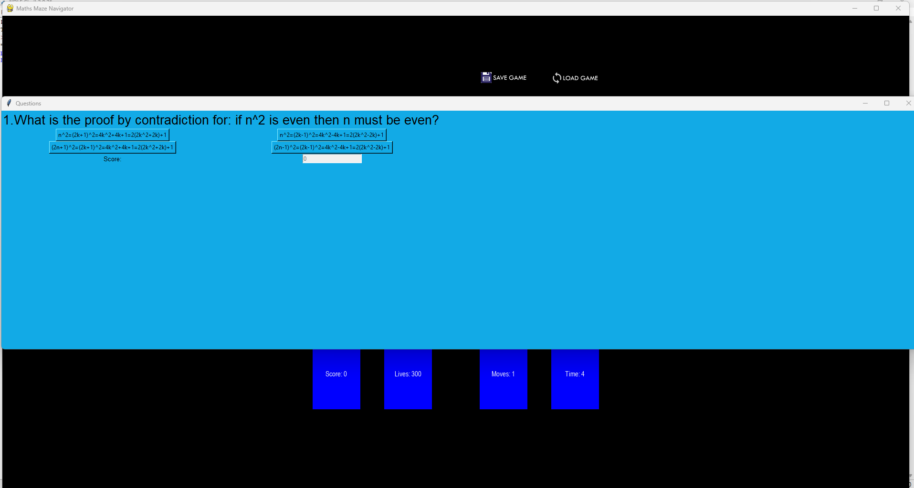

After answering first question correctly (closes automatically)

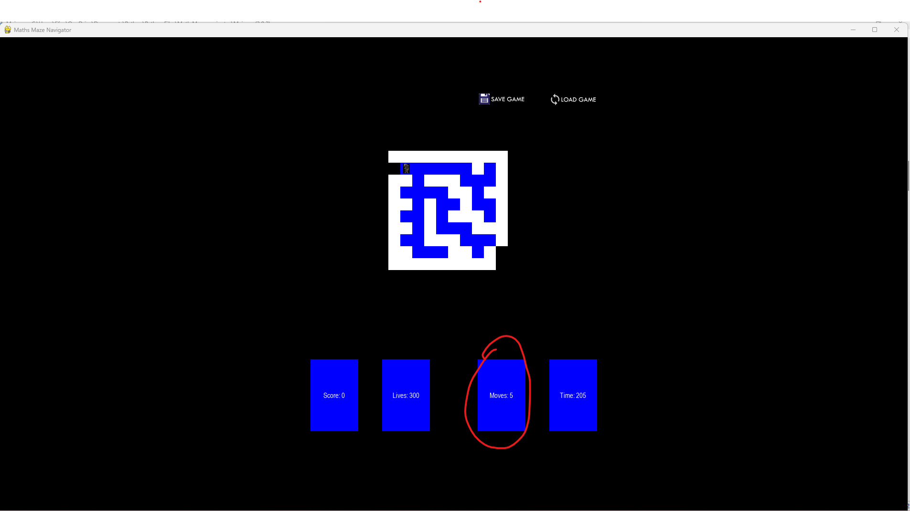

Halfway through the questions

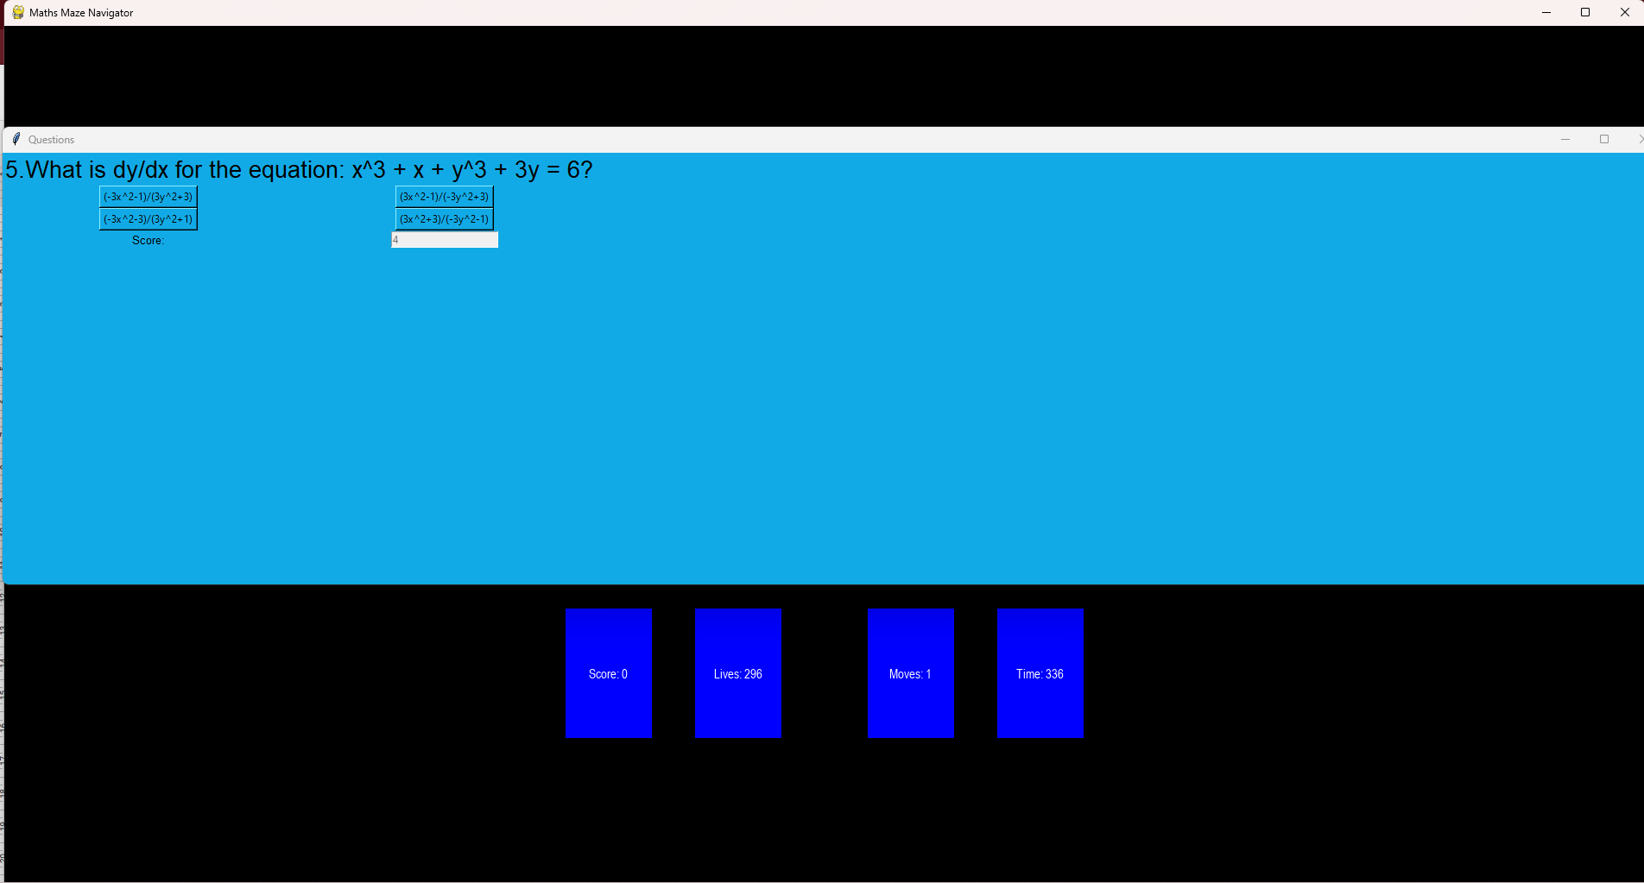

After losing all lives



About to complete the maze

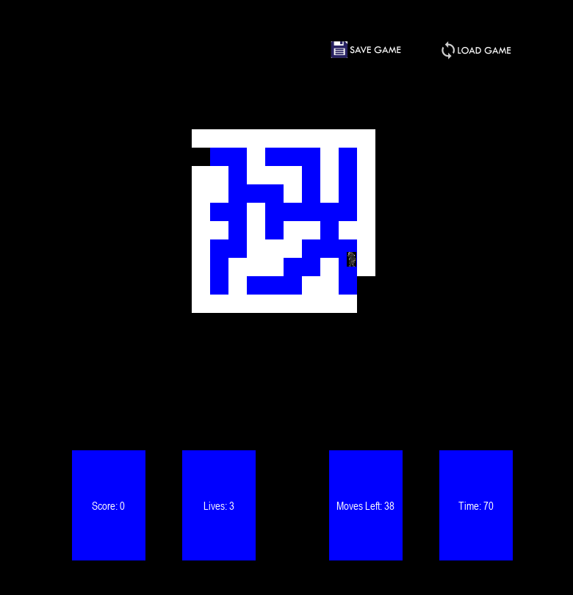

After completing the maze and clicking off the win screen

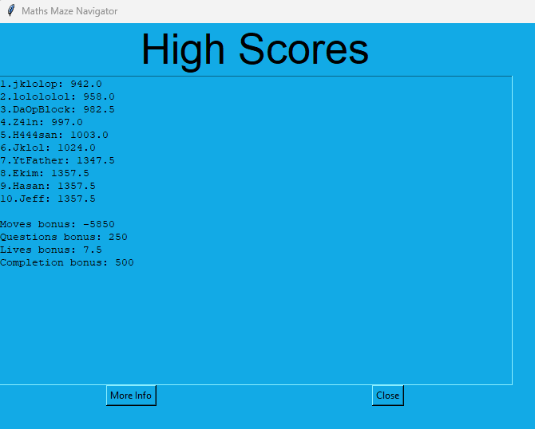

Final screenshot of ‘High Scores’

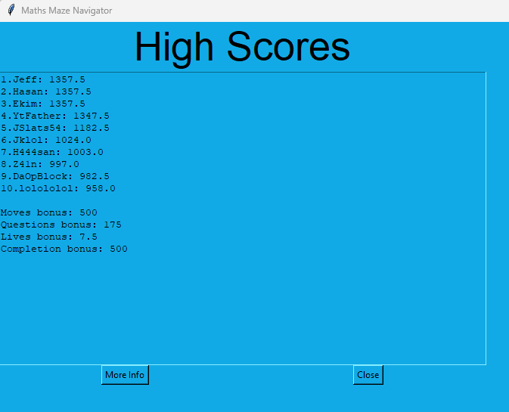

Next in this phase, an undo moves feature was to be added. This would allow the user to be able to undo up to 5 previous moves that they had made.

Firstly, a stack class was made to store the moves that the user makes

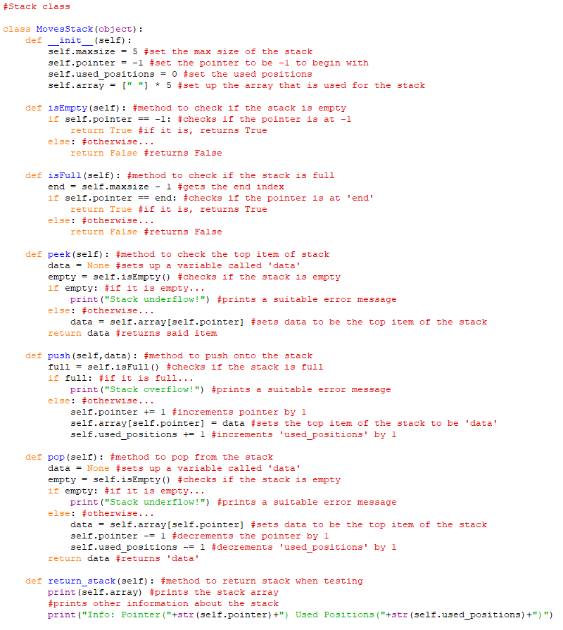

Also the ‘pygame_window’ class was updated to implement this

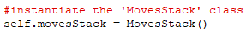

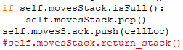

The output of the stack after the game has just started:

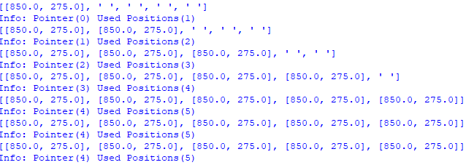

The Undo Button sprite was defined in the ‘Information_objects’ program

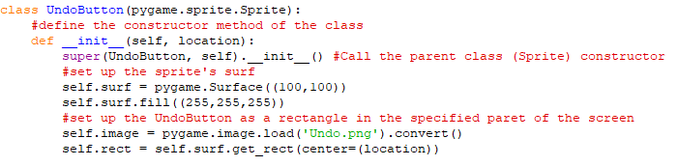

Next, it was instantiated in the ‘pygame_window’ class and blighted onto the screen

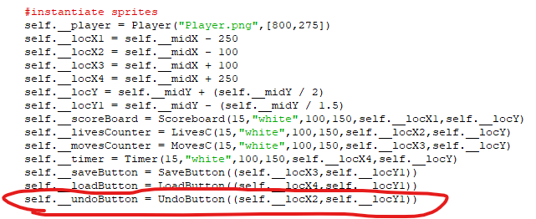

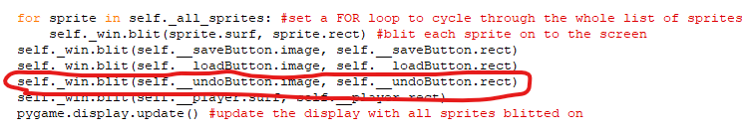

Here is the game with the undo button displayed

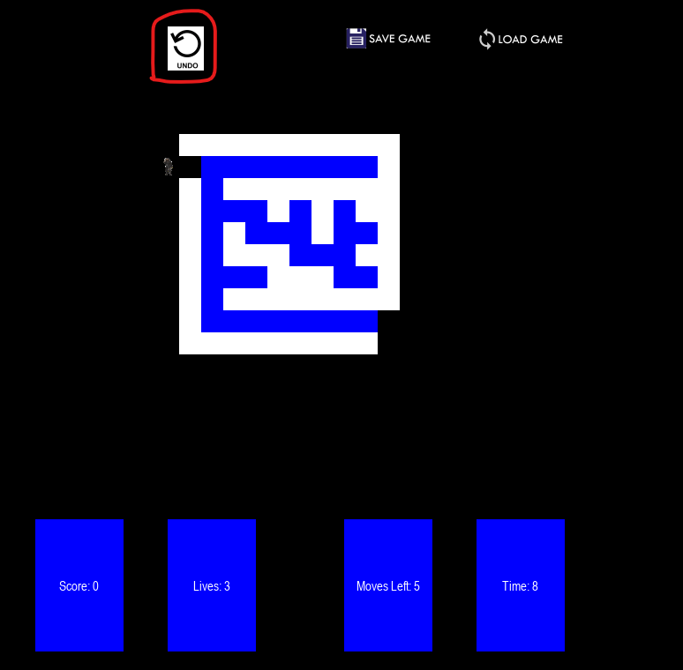

The next thing to do was to add the functionality of undoing moves

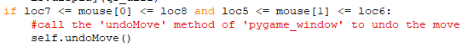

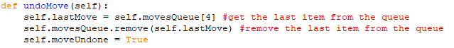

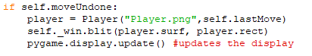

The game before clicking ‘Undo Move’:

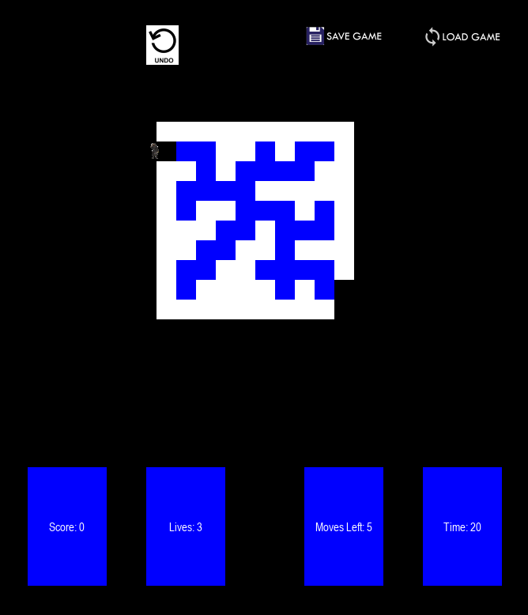

After clicking ‘Undo Move’:

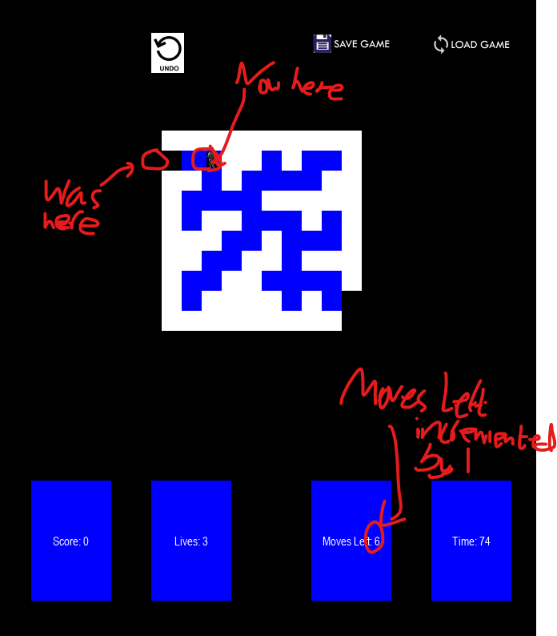

**Phase 6:**

In this Phase, a hints system will be created which will provide a hint in exchange for points off the score at the end. The hint will move the user to the nearest block that is on the correct path of the maze.

First, a ‘recursiveSolve’ function was defined that recursively calls itself

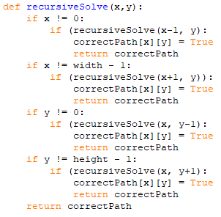

This was then called within the ‘generate_maze’ function

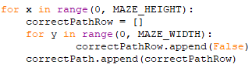

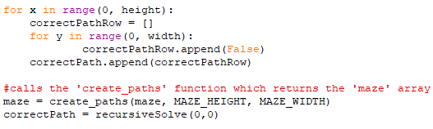

A function called ‘revealHint’ was defined

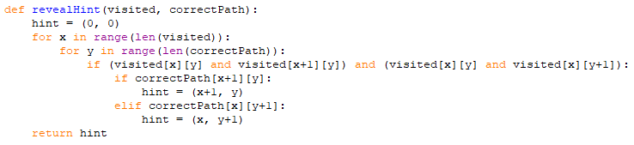

This was then called from ‘pygame_window’ and implemented

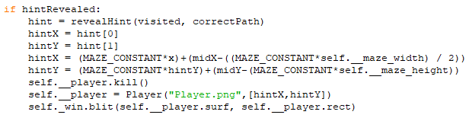

A ‘HintButton’ class was created in ‘Information_objects’

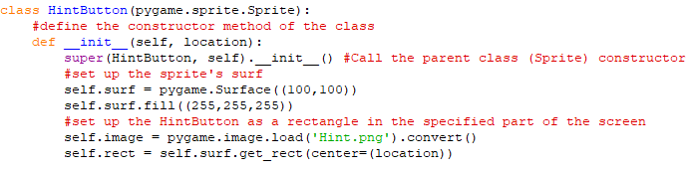

This was then instantiated and blitted onto the screen

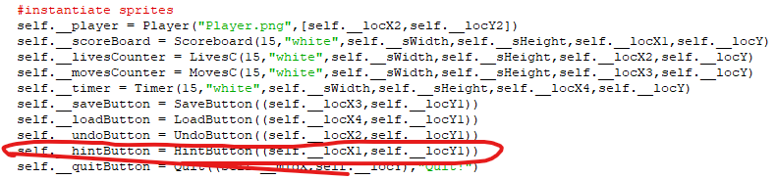

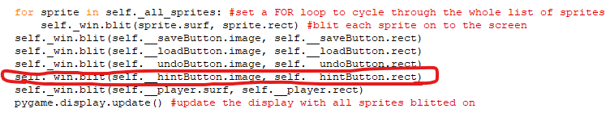

The ‘revealHint’ function was updated

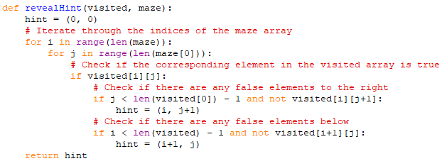

Before pressing ‘Hint’

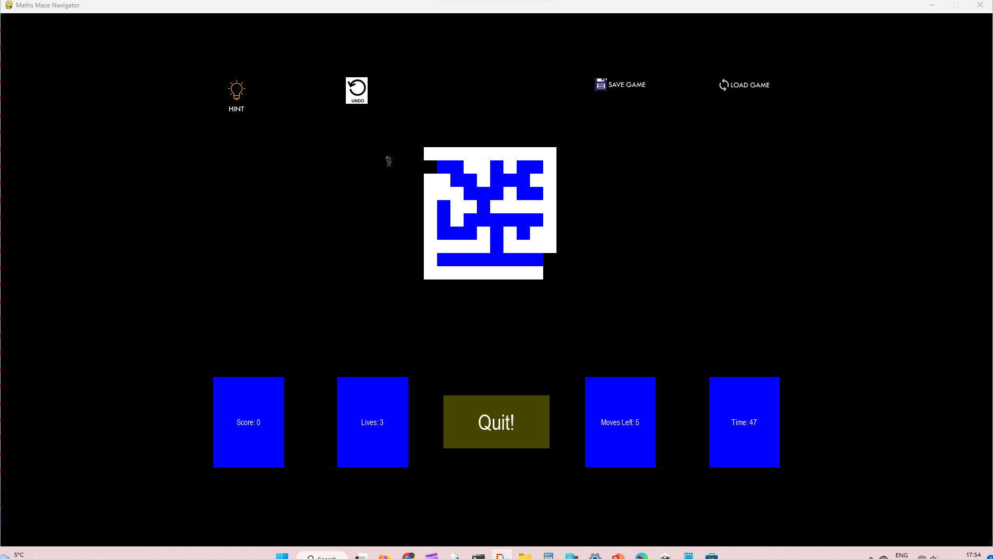

After pressing ‘Hint’

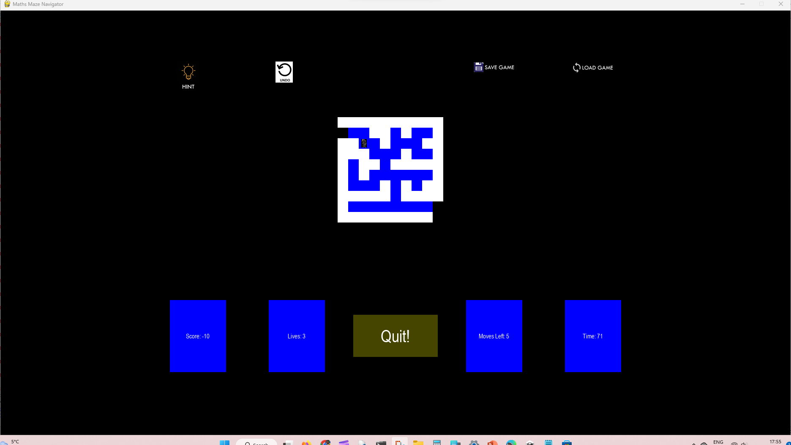

**Phase 7:**

In this Phase, the program will be finalised and then be ready for testing.

**Feedback:**

End-user Mr Ninson said:

“”

End-user Jacob said:

“About the controls, a good feature is that you can move with either WASD or the arrow keys which is useful. There is a toggle fullscreen feature but this does not always work properly. The graphics are quite good and the overall game experience is superb. However, when you crash into the wall, lives are lost at a tremendous rate and the player can still pass through the walls. If there is a way around this, it should be implemented.”

End-user Mr Ninson said:

“”

End-user Jacob said:

“The save game and load game feature is really good as you can load in a game you previously saved even after you have rebooted the game or started a new game, a previous game can still be loaded. Furthermore, the high scores are displayed in order at the end of the game if you win and how to play/instructions and control sections are very clear.”

End-user Mr Ninson said:

“”

End-user Jacob said:

“Easy to use interface complemented by easy to use controls and inputs. Issues include the glitching as you hit the wall and the odd spelling mistakes in the comments in the code (#). Overall good project and fine game. As far as I know, all the objectives have been met providing a useful final product which could be distributed and help students with their revision. Also, my suggestions were mostly taken into consideration and implemented into the game which I am pleased about.”

**Analysis by supervisor:**

This part of the document is a documentation of how each line of code of Maths Maze Navigator works written by the supervisor.

Each line that contains code will be explained. Each line will be documented and explained. Its purpose will be outlined and each line will be checked as to what function it serves and where it is used in the Maths Maze Navigator.

Comments are included as lines, but comments will not be explained.

**VERSION 1 (see Phase 1)**

Maths Maze Navigator v1 contains 3 python files - a Main program and 2 subprograms (called Player_class and Maze_objects) which can be summed up in 6 operations:

* Runs the main game window
* Instantiates a Player that can be moved with either the arrow keys or WASD
* Generates a Maze using 25x25 sprites (Blue for Cells and White for Walls)
* Allows the Player to traverse through the maze
* Kills the player and respawns them if they hit a wall
* If the Player gets to the end, prints a message saying “You win!”

NOTE: This was an early version of the program so only basic functionality such as navigating the maze was added. Other functionality such as the score, lives, moves and questions were to be added later on in the project.

**Player class:**

This subprogram contains the Player class, which contains the character you can control, as well as its movement.

Line 2 is where pygame is imported. This is used throughout the entirety of the player class to make up the attributes of the player without typing out each attribute (due to inheritance), allowing less code to be reused.

Lines 5-15 is where variables that store events such as pressing the ‘w’ key on a keyboard. Pygame.locals stores these events which can be used to set movements within a game loop. There is also an event for loading an image loading for run length encoding (RLE encoding) which is inserted as a parameter to allow for faster and more efficient insertion of an image onto a pygame window.

Line 17 shows that the class Player inherits from a pygame superclass called ‘pygame.sprite.Sprite’.

Lines 18-25 define the constructor method of the class Player. The constructor method takes in 2 parameters which are ‘image_file’ and ‘location’. ‘Image_file’ consists of the name of the file, and the location is the location of where the player will be instantiated. Line 20 shows the constructor method of the parent class pygame.sprite.Sprite being called. Line 22 shows the player image being loaded and stored inside a variable named ‘self.surf’. Line 23 shows the colour of the image being set as blue.

Finally line 25 shows the coordinates of the image being stored in a separate variable known as ‘self.rect’.

Lines 27-49 show the definition of the method ‘move()’ which takes 1 parameter known as ‘pressed_keys’. It contains 4 if statements which all check if a certain key is pressed and then allow the character to move. The final 8 lines stop the player moving off screen by checking the position of the character, then moving the character if they hit the wall.

**Maze Objects:**

This file contains the objects that make up the maze the character must move through.

Line 2 is where pygame is imported. This is used throughout the entirety of Maths Maze Navigator v1 to create the maze.

All classes (listed below) inherit from pygame.sprite.Sprite.

Wall:

* This class defines the walls of the mazes, which the player cannot pass through while inside the maze.
* It contains 1 method (the constructor) which takes in 1 parameter of ‘location’, and sets the colour of each wall to be white with rgb values of 255,255,255

Cell:

* This class defines the squares within a maze that the player can traverse through which do not contain any items of significance.
* It contains 2 methods:

1. The constructor, which sets the colour of the cell to be blue with rgb values of 0,0,255.
2. getLocation(), which takes no parameters and returns the private attribute self.__location to the main program.

Empty:

* Defines an empty square, which is used for the entrance/exit of the maze.
* It contains 1 constructor method which sets the colour of each empty square to be black with rgb values of 0,0,0.

Key:

* Defines the square within the maze which contains the key to exit the maze and win the game.
* It contains 1 constructor method (2 parameters are required, that being image_file and location)
* The colour is set to the same as an empty square (black with rgb of 0,0,0) however the image_file (the image of the key) is loaded inside the class. (This allows for the image file to be changed while the program is running without changing which image is loaded when initialising a Key class)

**Main**

The main program is where the main game can be played. The player can move their character through a generated maze and find a key, which allows you to win the game of the maze.

Line 2 imports pygame.

Line 4 imports the sleep method of time

Line 5 imports the randint and random methods of random.

Line 7 imports the Player class from the file Player_class.

Line 8 imports the classes Wall, Cell, Empty, and Key from the file Main_objects.

Line 10 assigns the value 10 to the constant MAZE_HEIGHT

Line 11 assigns the value 10 to the constant MAZE_WIDTH

Line 13 assigns an empty array to the variable maze.

3 main program methods:

1. surroundingsCells

* Takes 2 parameters [maze, rand_wall]
* Checks for the number of surrounding cells of the current cell generated,
* Returns s_cells, which stores the number of surrounding cells.

1. create_paths

* Takes 3 parameters [maze, MAZE_HEIGHT, MAZE_WIDTH]
* Starts by creating a random starting_height and starting_width, then adjusting them according to if they are equal to certain values [0, MAZE_HEIGHT-1, MAZE_WIDTH-1]
* Assigns True to the position of the starting_width and starting_height of the maze array.
* Assigns an empty array to wallCoords, then appends 4 values to wallCoords [the starting height-1 and the starting width, the starting height and the starting width-1, the starting height and the starting width+1, the starting height+1 and the starting width]
* Assigns False to 4 positions in the array maze [the same 4 positions of wallCoords]
* A while loop is used to create the paths of the maze.
  + A random wall is picked and checked to see if it a left wall, an upper wall, a bottom wall, or a right wall, in which in either scenario a new path can be denoted and new walls can be created depending on if the value of rand_wall[0] is not equal to 0 or MAZE_HEIGHT-1. This only occurs if the number of surrounding cells are 2.
  + After the while loop, maze is returned to the main program.

1. generate_maze

* Takes 6 parameters (MAZE_HEIGHT, MAZE_WIDTH, maze, walls, cells, all_sprites)
* A nested for loop is set up which repeats a total of 100 times (10 times for each row in each column, with 10 columns)
* The create_paths() function is called to generate the maze array.
* A different nested for loop is used to check if each row and column of the maze array contains ‘None’, where it is set to False so as to ensure the maze is generated there.
* The entrance (maze[0][1]) and the exit (maze[9][8]) of the maze are assigned the value ‘None’.
* A new nested for loop is set for each row and column which is used to group each square of the maze into its corresponding group, stored in the variable all_sprites.
* On the 9th row, a new sprite group is created which results in the subroutine returning keys to the main program.

Classes:

1. pygame_window
   1. constructor

* 3 parameters (MAZE_HEIGHT, MAZE_WIDTH, maze)
* Is used to initialise the pygame window, where pygame, and sprites are instantiated inside the class, with attributes being assigned their values.
  1. display
* generate_maze is called and the returned value is stored in a variable called keys.
* A game loop is set up, where unless the user closes the window the pygame window is constantly running. On each loop, the following occurs in descending order:
  + The pygame window screen is set to black
  + The previous key the user pressed is stored in pressed_keys
  + Another for loop is set which places each sprite in the variable all_sprites onto the pygame window.
  + The pygame window is updated.
  + The player is moved depending on the key they pressed
  + The current sprite is checked to see if it has collided with any walls sprites (any walls of the maze). If it has, the player is killed and respawned in the same position as if they had started the game again.
  + A variable (thisCell) stores the function used in the previous if statement but it stores the result of if the player collided into a cell instead.
  + A for loop is initiated where the location of the cell is returned to the main program if the player moves and collides with a cell [note this cell must not contain a key]
  + The player is checked if they collided with the key. If they do, the statement ‘You win’ is printed and the program is closed.

1. Game
   1. Constructor

* 3 parameters (MAZE_HEIGHT, MAZE_WIDTH, mase)
* Uses composition using an instance of the class pygame_window to initialise the main game window.
  1. run
* Calls the display method from pygame_window to display the pygame window.

FINAL IF STATEMENT:

* Initialises an instance of the class Game, then calls the run method of the class Game if before running the python file it detects that the __name__ of the program is equal to “__main__” which is always True unless the program is imported into another program i.e it is a subprogram.

**VERSION 3 (see Phase 3)**

Maths Maze Navigator v3 contains a 100 line python file (called Maths_quiz) which can be summed up in 2 operations:

* Opens a tkinter window which Welcomes the user to the Maths Maze Navigator.
* Allows the user to interact with the program using Tkinter buttons

The program imports everything from both the tkinter and random module.

get_questions()

Opens the maths.qs text file (this file stores the questions used in the program).

It stores the questions in an array “questions”.

Results (class)

Constructor method:

* Inherits from a parameter known as parent, and uses Toplevel to allow the results to be managed by the main program
* Constructs the geometry of the results screen, which shows the player’s score from answering the questions presented to them

Window (class):

Constructor method:

* Inherits from parameter parent (App class)
* Creates widgets which store the 4 choices for each question in the array, and displays these choices as possible answers to the question displayed.
* Sets the correct answer to the 1st answer in the array.

ansPressed:

* Requires the parameters, answer, and correctAnswer.
* Checks if the answer given is equal to the correct answer given. If this is true, then “Correct!” is printed to the main program and the score is incremented by 1.
* If not true,, then the opposite occurs, where “Incorrect!” is printed to the program and the score decreases by 1 (note, this means your score can go below 0)

open_window:

* Requires the parameters: score, and questions.
* Used to destroy the previous window and open a new window when a question is answered.
* Sets a variable calls to a global variable.
* Removes a question from the questions array
* Increments calls by 1, then destroys the window.
* Checks if calls are less than 10, where if they are, a new Window class is instantiated. If calls are equal to 10 (or greater than 10 somehow), a Results class is instantiated.

App (class):

Constructor method:

* Inherits from Tk
* Creates the window for the start of the program.
* Creates the label which states "Welcome to Maths Maze Navigator”
* Creates 2 buttons, which when pressed, perform different actions (1 button opens the questions for the user to answer, the other button closes the program

open_window:

* Defines calls as 0 (to be passed to Window class)
* Stores the questions in an array generated by the get_questions() main program function.
* Initialises a Window object with the parameters calls (0) and the question array (questions)
* Calls window.grab_set(). This means that the widget grabs all events for the application. In this program it also prevents multiple instances of the ‘Window’ class opening at once.

FINAL IF STATEMENT:

* Sets up a variable called score as an integer (to be passed into App class)
* Sets up a variable called calls as an integer (to be passed into App class)
* Instantiates the App class which is a Tkinter window (Tk)
* Does app.mainloop() which allows events to happen within the ‘App’ class
* Only runs if before running the python file it detects that the __name__ of the program is equal to “__main__” which is always True unless the program is imported into another program i.e it is a subprogram.

**References (for Technical Solution):**

<https://realpython.com/pygame-a-primer/> - Initial tutorial for pygame basics

<https://www.pygame.org/docs/> - Check pygame features throughout project

<https://realpython.com/python-gui-tkinter/> - Initial tutorial for tkinter basics

<https://www.geeksforgeeks.org/merge-sort/> - Merge sort algorithm

<https://github.com/OrWestSide/python-scripts/blob/master/maze.py> - Prim’s Algorithm

<https://www.freecodecamp.org/news/sort-dictionary-by-value-in-python/> - Sort Dictionary

Also a host of my old python files were used to help with the making of this program:

[Maze generator V2](https://drive.google.com/file/d/1ftK_SQraiH3ZvU0bmUkCjTEBmxQUW3kq/view) (to help generate maze)

[Snake in python](https://drive.google.com/file/d/1NBYzjAjm5U5Hty-YFNrg9Ixhgq9ItorA/view) (to help with setting up sprites and general pygame workings)

[Football Pong](https://drive.google.com/file/d/1eL28aV3cYFeh-AuRHWk9ISlLN1m-Uq1t/view) (to help with setting up sprites and general pygame workings)

[Pygame Windows Practice](https://drive.google.com/file/d/196MZIALyrR4EV_kVtH1sLcgjSgny0aqn/view) (to help with setting up different types of windows)

[Pygame buttons](https://drive.google.com/file/d/1HBC3rzhbBO311LX1GcVvYhg7BkUqOlU6/view) (to help setting up button sprites)

[Pygame Timer Practice](https://drive.google.com/file/d/1236dtdPvOwdI7QR7U5OB2ksyz0C3-So_/view) (to help setting up Timer class)

[Larger GUI project](https://drive.google.com/file/d/1O84uVX1C7h_UA5fUlF_UGfg3tk1U8TFS/view) (to help with Tkinter workings)

[Critters vs Aliens](https://drive.google.com/file/d/15jbXIllIo7duJci0xHitkqxW-N-ka74V/view?usp=share_link) (to help with class inheritance)

[Python Stack Practice](https://drive.google.com/file/d/1PGZ-Rh_UHDDE-6k9Dn4ObxJbixZLJ1Tr/view?usp=sharing) (to help with setting up MovesStack class)

[Python Queues Practice](https://drive.google.com/file/d/1_YHV0pnUbuQnsa48r_zeQcwUfUN4l-lj/view?usp=share_link) (to help with setting up MovesQueue class)